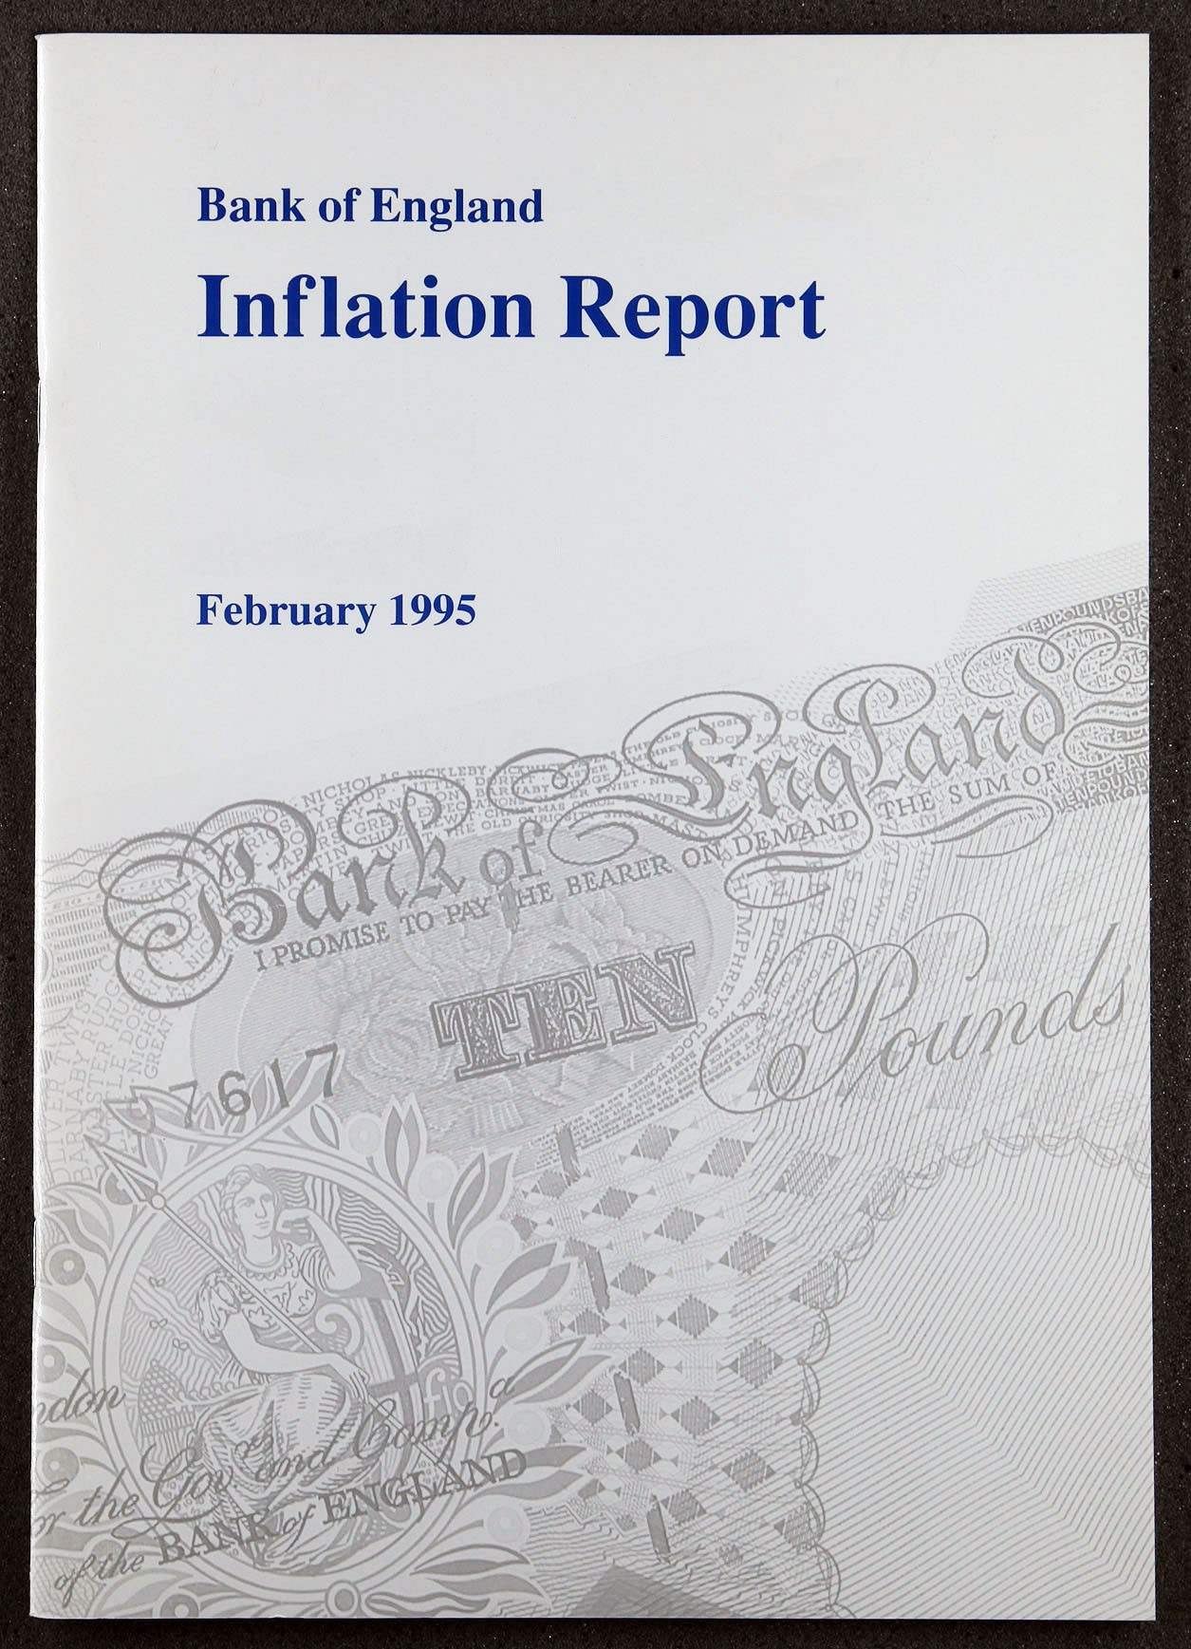

Inflation Report

February 1995

Recent developmen ts in inflation

###### Retail prices

1.2 Output prices

.3 Expenditure deflators Other measures of inflation

fiPf *Advise ry* Commifree

2 Money and interest rates

Money and credit aggregates 10

Narrow money 10

Broad money and credit

###### Interest rates and exchange rates

Interest rates

Exchange rates 14

Market expectations

* 1. Summary

*Note circulation. breakdown by denamination* i6

###### Demand and supply 18

Domestic demand \a

Consumption

The housing market 19

Investment 20

Government spending 21

3.2 Net external trade 21

Business confidence 22

Summary 24

The labour market 25

Earnings 25

4.2 Labour demand 26

Unemployment

###### Alternative measures of labour market tightness

Productivity and unit labour costs

4.6 Expectations

.7 Summary 32

Pricing behaviour

* 1. External influences

Overseas inflation and import prices

* 1. Profitability

Manufacturing Utilities Retailing

###### Summary 39

1. Prospects for inflation 40
   1. The economic news 40
   2. The Bank’s medium-term inHation
   3. Private sector inflation forecasts
   4. The risks to the inflation outlooh Conclusions 46

not availab

###### Symbols and conventions

— nil or less than hnlf the final digit shown.

Because of rounding, the sum of the separate items may sometimes differ from the total shown.

On the horizontal axes of graphs, larger ticks denote the first observation within the relevant period, eg data for the first quarter of the year.

Printed by Park Communications Ltd i Bank of England 1995

ISBN 1 85730 033 5

ISSN 1353—6737

Summary

All measures of inflation (except for services) have risen since the time of the November *Inflation Report.* The Government’s target measure of inflation—the 12-month rise in the retail prices index excluding mortgage interest payments (RPIX)—rose in November to 2.3% and again in December to 2.5%. The Bank’s **RPIY** measure which excludes indirect taxes .as well as mortgage interest payments—also rose.

Output has continued to grow at well above trend. though it slowed down during 1994. Labour demand has increased and unemployment has fallen more rapidly than expected. Pay settlements have edged up. The sharp dichotomy between export and domestic demand has meant that the capacity of producers of tradable goods and services has come under particular pressure.

The longer-term influences on inflation remain favourable. Broad money growth remained subdued in the fourth quarter. MO continues to grow at above its 0%—4% monitoring range, but, as expected, has recently been slowing down. UK gilt yields have fallen in the past three months and outperformed several other bond markets. Against a volatile international background, sterling has remained relatively stable.

There are still strong pressures from the costs side. Most commodity prices an‹i manufacturers’ input prices have been rising rapidly. Shorter-run measures of cost inflation suggest that the pressure on margins from this source has eased a little, but is still considerable. Further along the supply chain, the annual inflation of producer output prices has increased. Some of last year's compression of retail margins is likely to unwind as recovery eonti.hues.

**Without.the increases in interest rates since the previous**

2t•.r .*'i. •1ie/ Bank’s: **central projectioñ would now have been for inflation to be** in.the **upper half of:the target range.** As it is, **the Bank is:stiJl pr je.ctitig a rate two yeaMrs ahead of around**

**2'/i%:, the mid.point.,of the rang with the upside risks somqwhat less.than be%re. Tliii tighteniñg.of monetary policy since November has therefore imgr0*ed the prospect of achieving the lower.half** Gif **i:lie,tsrget range4iy:the end of** the @ **nt attrliament•**



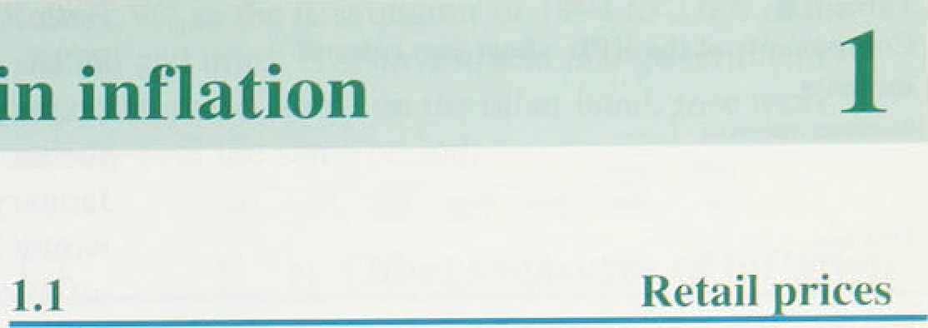

Chart 1.1



**'RPIY**

All measures of inflation (except for services) have risen since the time of the November *Inflation Report.* The Government’s target measure of inflation—the

12-month rise in the retail prices index excluding mortgage interest payments (RPIX was unchanged in

i• October at 2.0%, but then rose in November to 2.3%, and again in December to 2.5% (see Chart 1.I).

, Headline RPI inflation rose in each of the three months in the fourth quarter, by 0.2 percentage points in both

, October and November, and then by 0.3 percentage points in December. Its 12-month rate of increase was 2.9% in December, compared with 2.2% in September.

- - 2



9.4



Table 1.A

**Short-run:.measures of.inflation**





*RPI



As expected, the increases in duties announced in the November Budget, in particular tobacco, petrol and vehicle excise duties, added to inflation in December. However, the Bank’s RPIY measure—which excludes indirect taxes as well as mortgage interest payments— also rose. After falling to a low of 1.0% in October, RPIY inflation increased to 1.4&o in November and 1.7&o in December.

Table 1.A shows how short-run measures.of inflation

##### have varied during the past year. These .can give an

###### on of a turning-point in inflation but are



N n••. more volatile:than the longer-run measures. The seasonally adjusted three-month annualised figures all rose in December. The six-month annualized figures

that inflation has passed its trough.



The.increase in inflation was spread across most



6*r0ontb. ’ 1:S .0-*. ! *' 1.S 1.2 1”.2. 1.4

COmponentS. Of RPIX (see Table 1.B). On a three-month 2 4 annualized basis, inflation in the household goods sector '.* increased tluoughout t994; in the car sector, it !started to



4

, , increase in the summer. Inflation in the clothing and



###### .°• footwear sector turned up 4n December, as discounts

, , seen in the autumn were withdrawn.



o: '

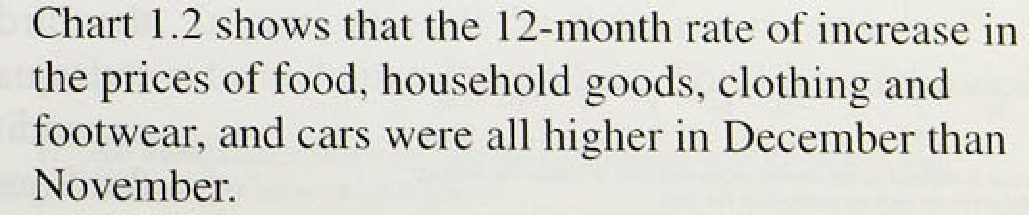

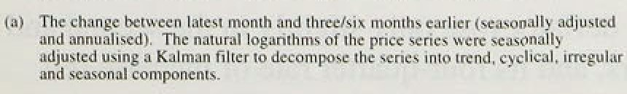





**L"‹›mp‹›nci ts uf the** RPI: **sh‹›rt-run rales** uf

m‹ rt. xc







RP X cIr›LhitI¿r and Ii›‹›twe;tr

|  |  |  |  |  |  |
| --- | --- | --- | --- | --- | --- |
| .i•int›nt h fLl | it,-1 | -1.0 | 0.3 | — -p.2 | tj. |
| 5-mnnih I .4  kl’IX h‹ u rh‹›I I u‹ udx | 0.3 | -II.? | -If.1 | — IU | IT.4 |
| t›-iuornh 1 .II | -0.1 | tLfi | 0.7 | I .9 2.7 | 2.7 |





Rrtiiil prices





Both RPIX and RPIY are!sutiject to.seasonal ?ariatiofis. R.PIX, for example, tends. to increase most in April (mainly because of changes in adiiiinistered /prices

such as rents and local authority taxation) and least in January and July, because of the traditional timing of winter and summer sales. The short-run measures of inflation which show turning-points are seasonally adjusted to take account of these effects. But seasonal adjustment is not straightforward: the timifig of sales and the extent of discounting cou1‹i reflect either a

.change in the underlying trend of inflation or a change in the seasonal pattern. In 1994. for example, the early

su mmer and winter sales were probably .a sign of weakening retail margins and not just d changed seasonal pattern.

The Bank’s new short-run projection for RPIX inflation (Chart 1.3) shows a further rise in the first quarter. It allows for the increases in duties announced in the Budget and the Chancellor’s supplementary statement, which are likely to add around 0.3 percéritage points to RPIX inflation in 1995 Q1.

#### ' 1 2 Ou es



- - 2



9: 93 .9*



RPIX inflation projections and oiitturns



Twelve-month output price inflation rose from 2.37c .in September to 2.69 in December. If the more volatile prices of two sectors—food, drink and tobacco, and petroleum refining=—are excl.uded; the rise. was slightly stronger, from 2.1% in September to 2.89r in December. Short-run measures also pieke‹i .up; the seasonally adjuste‹i three-month annualised rate excluding the ltwo volatile sectors rose from 3.6% in September to .4.3% .iii December. Cost increases continued.to pass.along the manufacturing supply chain and further increases.in producer price inflat'ion are expected.. The relationship between producer prices and retail prices fs discussed in. Section 5.

### 3 te to s

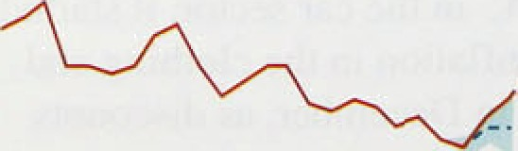e

:de at r r.the m**heir nua es of’ncpandi** nre ed’cm° the: National,Accpunts. Thesé provide comprehensive. measures of inflation,1but are’less up-to-date than other indicators. The impl,ied GDP..deflator.rose b.y. 0.7 in the third quarter,. after being flat in. the second. Its

!fofi-gunner rate of increase was 1.6&o. The consumers’



,expenditure.deflatour rose only slightly in the second.and third quarters, and its four-quarter rate of increase fell





Tstile 1:C

**Expenditure deftutors**

.'Perocr!teg* changes..on'a y*ar carlied



1.992



|  |  |  |  |  |  |  |  |
| --- | --- | --- | --- | --- | --- | --- | --- |
| -1993 Q I | 3.6 | -0:5.' | 6.2 | 3..6 | 10:2. | 8.8: | 4.3. |
|  |  |  |  | 3.2 | 9. I | 9.9 | 3.4. |
|  |  | I . j | 3.0. | 3.2 | I I . I | I0.9 | 3.4 |
| Q4 | 3.2 | 0.7 | 3-2 | 2.9 | 6.d | 3.2 | .4.1 |
| 2,4 | | | | | -0;'i | -.0.8 | 2.6 |
| Q2’’ | 2:6 | .0.3: | 2’.5’ | 2.3 | 0.2 | 2..2 | 63 |
| Q¿’ | 2.6 | J.2 | 3.0 | 2.5 | l.1 | 3.0. | I.G |
| .Q2 on.g I | e0:6 | .0:6 | 0.7' | 0:9 | 0.4. | 3. I |  |



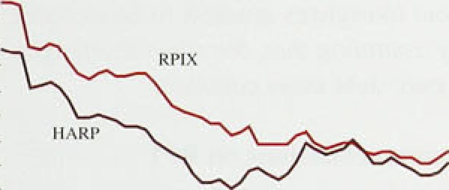

- 2’

.TI£ARP’’mO:IBPIY

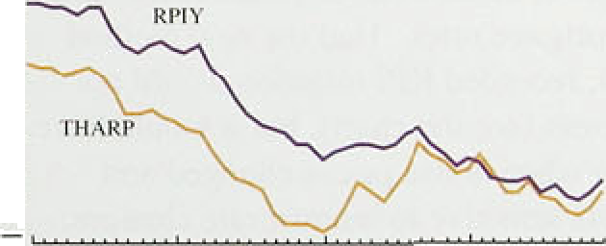



- 0



from 2.9& in the first quarrel of 1994 to 2.6% fn the second and third. The investment and government expenditure deflators, on the other hand, rose more rapidly over the same period.



Both RPIX and RPIY measures exclude mortgage interest payments and hence any impact of changes in the cost of owner-occupied housing. The

housing-adjusted RPI (HARP index) attempts to rectify this omission by adding a Bank estimate of the user-cost of housing to the components of RPIX. Indirect taxes can be excluded from the HARP index to provide an alternative to RPIY—the THARP index of tax and housing-adjusted retail prices. Because of the continuing weakness in house prices, HARP and THARP inflation rates have been below the corresponding RPIX and RPIY rates, although they too picked up during

the fourth quarter (Chart 1.4). HARP and THARP inflation stood at 2.0% and 1.3% respeeti¥Rly in December, compared with 1.5% and 0.8% in September.

###### Chart .I.5 shows RPIY and two other measures of inflation which attempt to allow for the potentially distorting effect of large movements in relative prices. The median inflation measure uses all the component RPIY price series to compute a median rate of change for each month. A variant of this approach is to exclude the largest and smallest price changes to give a ‘trimmed mean’.( Although the trimmed-mean inflation measure tracked RPIY quite closely during 1954, the median inflation rate was lower, suggesting that the ldistribution of price changes was skewed upwards. The trimmed-mean.and median rates, on both 12-month and three-month annualised bases, turned up in the fourth quarter.



The Tax and Price Index (TPI) adjusts the RPI for changes in direct taxation to obtain an index of consumers' purchasing power. TPI inflation rose to 3.4% in December from 2.6% in September.





— • .Most measures suggest that'inflation has now.passed its

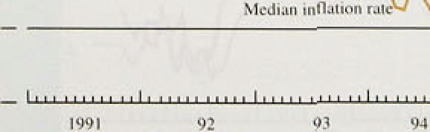**trough. .'In** paiiiéiilar;:nl1 the short-run measures of



###### * ' inflation turned up!in December. The 1:2-month rates of



7

**RPI Advisory Committee**

The Retail Prices Index Advisory Committee (RPIAC) reported in December 1994 on the treatment tif

owner-occupiers’ housing *costs* rind car prices in the retail prices index (RPI). In framing its recommend‹itions, rhe Committee was asked to take account of practices in

other European Union countries. Its proposals. which were formally accepted by the Chancellor on 5 January, mainly concerned the treatment of housing.

The Committee concentrated on the shelter costs of owner-occupiers, at present estimated by a mathcinatical model of mortgage interest payments (M IPs) and ii‹›/ by actuat payments, lt recommended that the RPI should continue to include montage interest payments as a coinponeni of owner-occupiers’ shelter costs. but thut a new e lement should be included to represent the cost of

*Deyreciatiaii.* in addition to ihe housing repairs and maintenance category already included in the R PI. an element of depreciation is to be incorporated. Thc depreciation rate will be derived from the naiional accounts model of housing capital consumption. The

years and will be reviewed annually. The price indiciitur will be bosed on a house price index. Hence the inclusion of depreciation will introduce house prices into the R PL

Althoup•h it was recognised that there is no unique way uf treating owner-occupier housing costs, the inclusion of depreciation does not remove the problem that :tn increase in interest rates which will reduce underly ing inflation will increase the I 2-month rate of RPI inflation for 12 months. An alternative way of treating

owner-occupier costs would be to treat them as the costs of hiring a consumer durable. The Bank’s HARP index incorporates an estimate of lhe user-cost of housing. The HARP index does not respond to interest rates to the same extent as tne xri.

Other changes to the index will include:

*Change of snmple.-* where possible, the input data series should match the sample of households represented in the RPI. This sample is based on the Family Expenditure

*Change to the equity* Wfrfidrnu'o/ *axrumpiiori:* the

ex isting **RPI** calculation already removes an element of equity withdrawnl from the estimate of mortgage interest costs—that is, the interest cost of borrowing secured on housing, but used for purposes other than house purchase. However, the increasing incidence of equity withdrawal has meant that this adjustment is insufficient. Rectifying this means adjusting downwards the estimate of the average percentage of the house purchase price which is borrowed for housing purposes. The RPiAC

recommended that it be reduced from 65a to 55a, and that this figure be kept under review.

<J••*^e* *‹! ‹tsS*ff *lTtptinns concerning type of moi tgage:* the current index assumes that all mortgages are of the repayment type and thus measures only interest

payments. Capital repayments are treated as an element of saving and therefore not a housing cost. The outstanding debt on a repayment mortgage and, consequently, mortgage interest payments (MIPs) fall over Endowment mortgages are now to be included in the M IPs model by assuming that, for some mortgages, the outstanding mortgage debt stays constant.

E“.f’l’ect of' housing **recnnimendations on RPI**

The pi oposaJs concerning equity withdrawal, endowment mortgagcs and depreciation will change the weights within the RPI. The p•eneral effect will be to give greater importance io changes in current house prices and slightly less to changes in mortgage rates. Had the new method been used in the past, recorded RPI inflation would not have been very different (see the chart), but it would have reacted more quickly when house prices changed and have been slightly less sensitive to interest rate changes.

These changes to the RPI will be introduced in the index for February, released in March, at the same time as the annual revision to RPI weights.

###### RPIX and RPIY inflation have also risen; they are expected to increase further in the first quarter of 1995.

Mone and credit a re ates

Broad money growth remained subdued during the fourth quarter. M4’s 12-month growth rate was 4.59r in December, well within the lower half of its 39 —9% monitoring range and a little lower than in September. Credit growth, however, picked up from 3.7% in September to 4.6% in December. The 12-month growth rate of M0 remains above its 0%—4% monitoring range, although recent data indicate a noticeable slowdown: it was 6.4% *in* January, compared with 7.3% in October (Chart 2.1). The three-month annualised growth rate of M0 was 2.6% in January.

In the three months to October, monthly notes and coin growth averaged 0.5%—slightly lower than in the first half of the year, but still higher than anticipated.

However, in the three months to January, notes and coin growth averaged 0.2% peT month. As a result, its

I 2-month growth rate fell from 7.1% in October to 5.8% in January, and the three and six-month annualised increases—at 2.6% and 4.69r respectively— were the lowest for over two years (Table 2.A). The reductions in interest rates between September 1992 and

February 1994 had been expected to increase narrow money growth by reducing the opportunity cost of holding cash balances. As expected, this effect began to wear off by the end of 1994.

1994Q1 lSy4 Q3 1954 Q4

In the past, narrow money—particularly notes and coin—has been a good guide to trends in retail sales. Much of the increase in the value of retail sales in the three months to December was the result of sales of more expensive items, such as household goods, which tend to be financed by credit. The slowdown in the growth of food sales, which are more likely to be cash financed, may have contributed to weaker narrow money growth.

One explanation put forward for the rapid growth of narrow money during the past two years is that there was an increase in unrecorded activity financed by

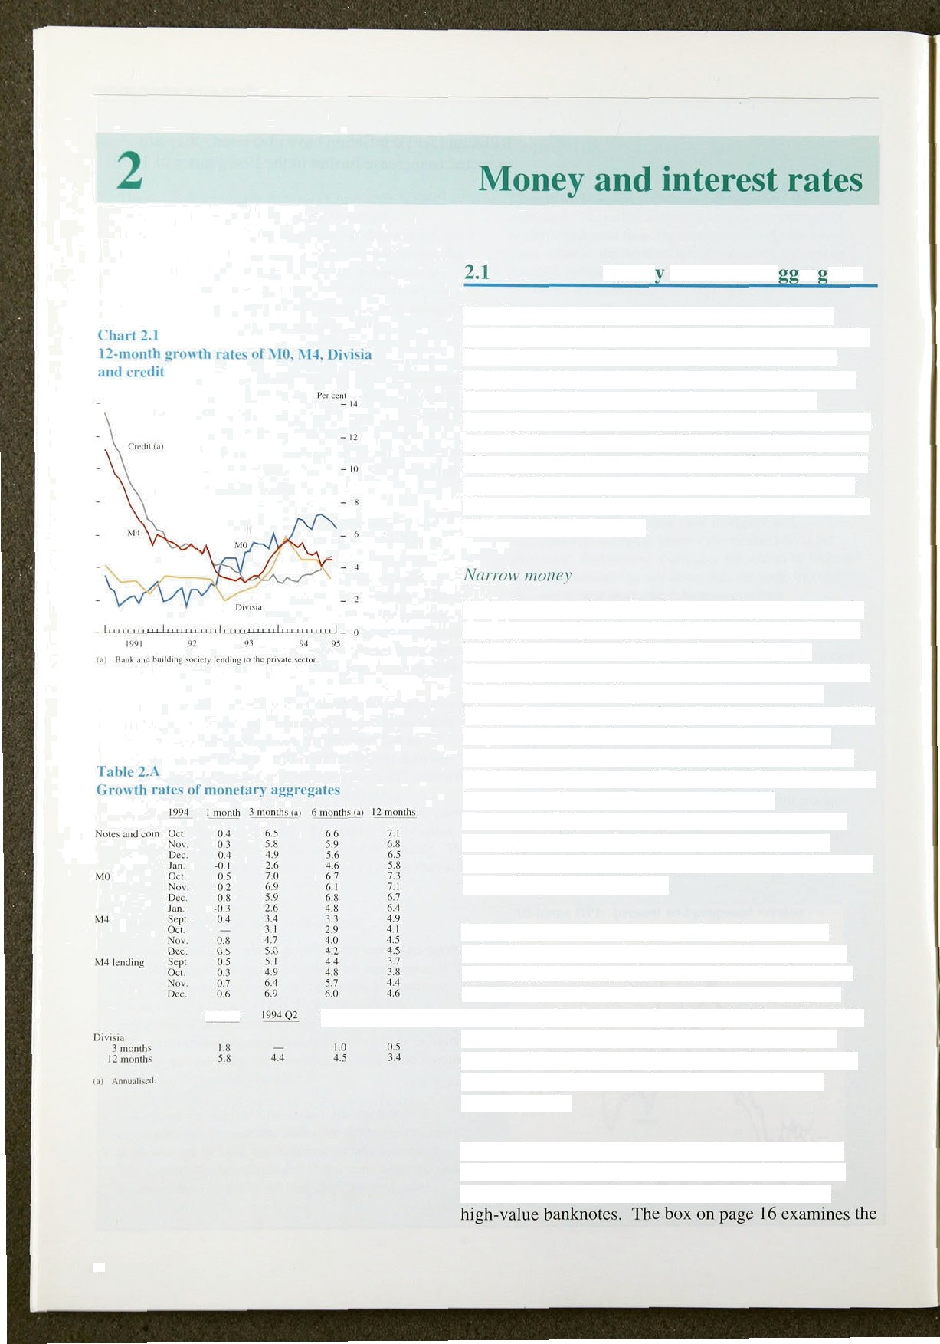

10

*Mancv and iylcrest ratcs*

use of different denominations of notes in circulation and.finds no evidence to support this hypothesis.

*Bmnd mo*n*ey and credit*

M4 growth .continued to fall in the fourth quarter. Its 12-month growth rate stood at 4.5'7r in December,

compared with 4.9% in September and its recent peak of 5.69c in March. Shorter-run measures of M4, however, picked up: its three-month annualised rate increased from 3.4% in September to 5&r in December. Bank and building society lending speeded up: it increased by

1.79 in the fourth quarter, compared with an average of 0.9&a in the previous three quarters. The 12-month growth rate of bank and building society lending was 4.6% in December, compared with 3.79c in September.

**Chart 2.2**

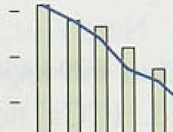**Personal sector borrowing**



An article .on pages 46r-53 of the February *Quarterl y Bulletin* examines the factors influencing broad money growth. Broa‹i money, M4, is used both as a means of payment and a store of value. Increases in M4 usually indicate increased future spending, because they signal either increases in perceived wealth or planned increases in transactions. But different types of agent— individuals, industrial and commercial companies, financial institutions—have different motives for holding M4. It is therefore helpful to look at M4’s sectoral components.

Individuals’ holdings of bank and building society deposits rose by E2.9 billion in the three months to December. Although slightly lower than the £3.0 billion recorded in the third quarter of 1994, this was higher than the average of £2.0 billion per quarter in the first half of 1994. Lending to individuals by banks and building.societies rose by £6.5 billion in 1994 Q4, the strongest .recorded increase since 1991 Q4. This growth reflected a pick-up in both mortgage and consumption lending (Chart.2.2).



Growth in lending for consumption by the banks and

:building societies has been very low in the.current recovery: Consumption lending, however, rose by

£1.2 billion in the.fourth.quarter—the:strongest.quarterly Increase since :19.89 Q3,. Banks’ credit card lending was



:f0.5 bi!llion, bthe highest.since. 1990 Q4. .Other bank

/c,redit—per4onaJ loans and overdrafts increased by

£0:.8.billion. This demand for crefiit appears consistent

.,(I)‘



lullaiiuu Rcpoy: February l99S _

Chart 2.3

**Total quarterls' sterling horror 'ing by**



with stronger contributions to retail sales from non-food items, particularly household goods.

As discussed in Section 1, retailers appear to have avoided further reductions in .the prices of household goods in the fourth quarter by offering special finance deals on items such as electrical goods and furnishings. Many of these deals are likely to have been financed by bariks and finance houses, and the growth in expenditure on household goods is therefore consistent with the strong increases in both credit card and other consumer lending by the banks. Specialist lenders (other than banks and building societies) increased their lending by

£0.4 billion in 1994 Q the strongest rise since the series started in 1987 Q1. The 12-month rate of increase of total consumer credit was l I to in .December, compared with 9% in September.

Borrowing for consumption accounts for only around 10% of individuals’ borrowing from banks and building societies. Mortgage lending, which makes up the other 90%, increased by £5.2 billion in the fourth quarter, slightly higher than in the second and third quarters of 1994. Within this, banks increased their lending by

£2.1 billion and building societies by £3.1 billion. Using the wider definition of mortgage lenders, net lending remained stable in the second half of 1994: specialist lenders were nol as active in the mortgage .market as earlier in the year.

Contrary to the experience in preivious recoveries— when industrial and commercial companies {ICCs) increased their borrowing—ICCs have made less hse of debt financing in recent years, preferring to.issue equity. Indeed, for in



1993 Q1,..the.y made net repayments of.debt. .Net

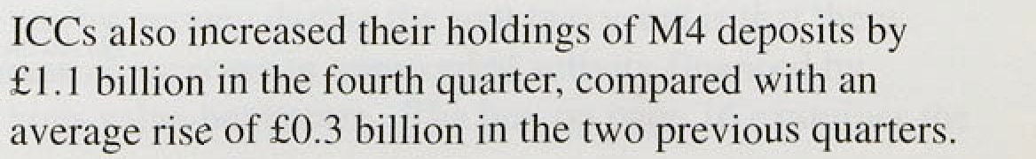, „ „ borrowing was roughly zero in 1994 Q3, and in 1994 Q4



###### positive net borrowing (El.5 billion) resumed. ICCs’ net

- • sterling capital issues were also stronger in the,.fourth

‹ quarter at a seasonally a‹ijusted £3.4 billion (Chart 2,3),





British companies now appear to be in a strong financial position and are able to increase investment using their own .internal funds. A recent survey by the Bank Consultancy Group reported that the availability and cost of bank finance i:s less of a concern to companies than it

was i.n 1992,

**Cbart 2A Interest rates'**











- 3.6:

*Divisiu*

The Bank’s Divisia measure of money, which weights the various components of M4 according to their transactions characteristics, rose by 0.59• in the fourth quarter, less than the strong increase of I.09o recorded in the previous quarter. This gave a four-quarter growth rate of 3.4%. Personal and corporate sector Divisia increased by 0.29r and 1.69• respectively in 1994 Q4; their l 2-month growth rates fell to 2.6% and 6.1%.

### 2 Inte e t ates d e ch ate

###### Developments in the financial markets affect the assessment of future inflation in three ways:

First, they may affect the outlook for aggregate demand. For instance. an increase in long-term interest rates is likely to reduce planned investment.

Second, financial capital flows can alter exchange rates and import prices. An unexpected tightening in domestic monetary policy, for instance, is likely to lead to a temporary appreciation, and therefore cheaper imports for a time.

###### Third, financial markets provide information about their participants’ average inflation and interest rate expectations. The higher are inflation expectations in the short run, the larger will be the price increases sought by producers. The higher are inflation expectauons in the long run, the less is the long-run lcredibility of monetary policy.

*.Interest rates*

###### Ten-year gilt yields fell by 29 basis points between

2fi October (the closing date for financial data used in the November *Report)* and 2 February, to stand at.

8,55d, This change was small relative to intra-period volatility.: Chart 2.4 displays the ten-year gilt yield

,together with.a selection of other .interest rates. Yields ’on index-linked gilts provide .estimates of real interest rates. Chart 2:5.shows that they .have increased slightly **since th*e l*as*t*** *Report,* and **are** still **higher** than at the







L!iyJtcJ X.in¿d‹›iTi

Dute C'hange Currcn l

* 2fi 7.40

l2isc'›iint rate +7'i 4.7y Ba.se rajc 7 l3cc. +'i0 6.?'\

The 50 basis-point rises in UK short-term .official interest rates on 7 December and 2 February had a positive market impact. Following the December rise, sterling rose in effective terms from ,85.2 to 89.3;( it increased slightly against the dollar from $1.5630 to

$1.5642. One-month interest rates rose by only '/ •%; rates beyond three months held steady or fell; and

long-term inflation expectations ° were revised down .on

l'inland Tender rutv 9 Gec. +40 3.5u



   

Chiirt 2.6

L K **and** t **rade-» sighted** world **interest rate**

yield rurs es



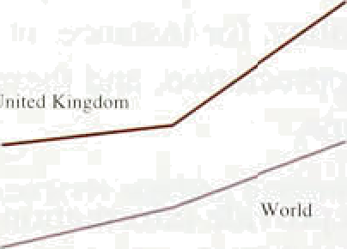- 8.0

— - 6.5

l•mnnf 0 ment t2•mouñ

**UK trade-weighted** interest **rate differentials**



— 1.0

i4

the day—although this decline was less significant and

more short-lived than the one following the rate rise in September.

###### Most mortgage lenders announced an increase in their variable mortgage rates following the half-point rise in base rates in December 1994, though generally not by the full:amount. The average variable rate (taking the five largest banks and building societies) was 8.27% on I February, compared with 8.1 I &• a month earlier.

The February increase in official interest rates appeared to have been generally anticipated in the financial markets. Sterling fell slightly against.the Deutsche Mark to DM 2.405 at the close on 2 February, compared with DM 2.4083 a day earlier—and rose a fraction against the dollar to $1.582 from $1.5815. The three-month interest rate implied by the futures contract for March 1995 fell slightly and there was very little change in the three-month rates implied for later dates. Long gilt prices fell a little,. but outperformed the German and .US government bond markets; long-term inflation expectations were unehangeft on the.day..

Official interest rates.have risen in a number of,countries since the November *Report* (see Table 2.B). .However, as a result of the tightening.of policy in Deceriiber,

short-term rates in the United Kingdom have.incre.ased

.by more.than.the.trade-.weighted wor!d average,!raising the short-term interest differqntial 9ver the pastlthree months (Chart 2.6). For three-month interest rates,:the differential on



compared with 30 basis. points:at the time nf the

!previous *Re!por.t;, Ioz* .12-month rates,. the.differentials were .109 and 91 basis pqints,respective1.y,

.(l)' A note. explaini9g **the:neW** sâlw,1atlpn o.ftJineffecttve **rati indss**

.iñéluded in

**,(2)! As measured by reference.to** ihr **yfelds on!.eiint0nii'on£l anfi index-** d











2.4K-













- t.56

movements against, the Deutsche Mark (Chart 2.7). The dollar strengthened immediately following the Mexican peso devaluation on 20 December (with .investors switching to dollar assets) contributing to a fall in the sterling effective rate (ERI). Sterling weakened against the Deutsche Mark during January, as the latter attracted

‘safe-haven’ funds.

Sterling’s effective rate was expected to depreciate slightly at the time of the November *Repon.*

Three-month interest rates were .higher on average in the United Kingdom than abroad; for expected returns to be

- Effccii '.c i ride* - fl9.6

- - 88.4



Chart 2.8

**Sterling interest rate expectations‹•›**













**Chart** 2.if

**linplied ten-year forwaid** inhstion **rales‹••**



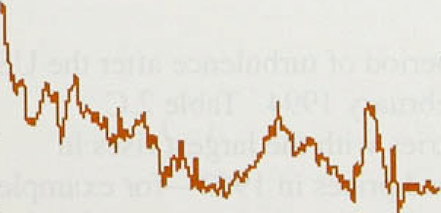

equalised across countries, sterling would have had to fall by around 0.29 over the following three months. In

the event. sterling’s effective index depreciated by 0.8&•, compared with a rise of 3.1% in the dollar index and 1.2% in the Deutsche Mark index. The depreciation took place despite the increase in the trade-weighted interest rate differential in favour of the United Kingdom, which would have tended to strengthen the exchange rate unless it had been entirely discounted in advance. This suggests that market participants revised downwards slightly thelr view of the likely long-run nominal exchange rate during the quarter.



The current structure of short-sterling futures prices suggests that the markets expect further rises in interest rates, although the implied interest rate profile is slightly lower than at the time of the November *Repori* (see Chart 2.8). On 26 October, three-month rates in the futures market were 7.59r for March 1995 contracts and

.8.9% for December 1995 contracts. However, by

2 February implled rates had fallen to 7.Ono for March 1995 and 8.4&o for December 1995. Implied forward rates suggest that short-term interest rates are expected to reach a peak of around 9.0% in around 1998. Actual market expectations, however, may be lower than this as futures .rates and implied forward rates embody a risk premium. Futures contracts are used as hedging

instruments for shori-maturity gilts, swaps and fixed-rate

mortgages. If, for example, market participants were

.risk-averse, increased uncertainty over three-month rates

.(related to uncertainty about the timing and size of prospective base rate rises), might lead to a higher risk prqmium being incorporated into short-sterling futures rates.

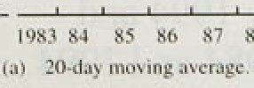g. , „. ',j , . • Chart'2:9 shows. an esti:mate of the 12-month inflation ” mte:expected ñy tire gilt market ten. years ahead. As



## Note circulation: breakdown by denomination

There has been speculation recently that unrecorded transactions have boosted narrow money growth. It is almost impossible to quantify the effects of the ‘underground’ economy, but

‹additional information may be gained by examining the use of different denominations of banknotes in circulation. If a large proportion of the £50 notes in issue circulaie mainly in the

of the denomination might reflect such unrecorded expenditures.

The chart shows, however, that the 12-month increase of £50 notes in circulation has slowed since mid 1993 and, for the first time since the

£50 note was introduced in 1981, the outstanding stock fell in the year to November 1994.

In the past l5 years, there has also been a marked decline in the value of £5 notes in circulation.

And more recently, the amount of £10 notes has fallen. The number of £20 notes, on the other hand, has increased strongly. The most obvious explanation for this is the increased issue of £20 notes through cash dispensers. The chart shows that the l2-month rate of increase in £20 notes in circulation has remained fairly constant, at around 15% over the past two years.

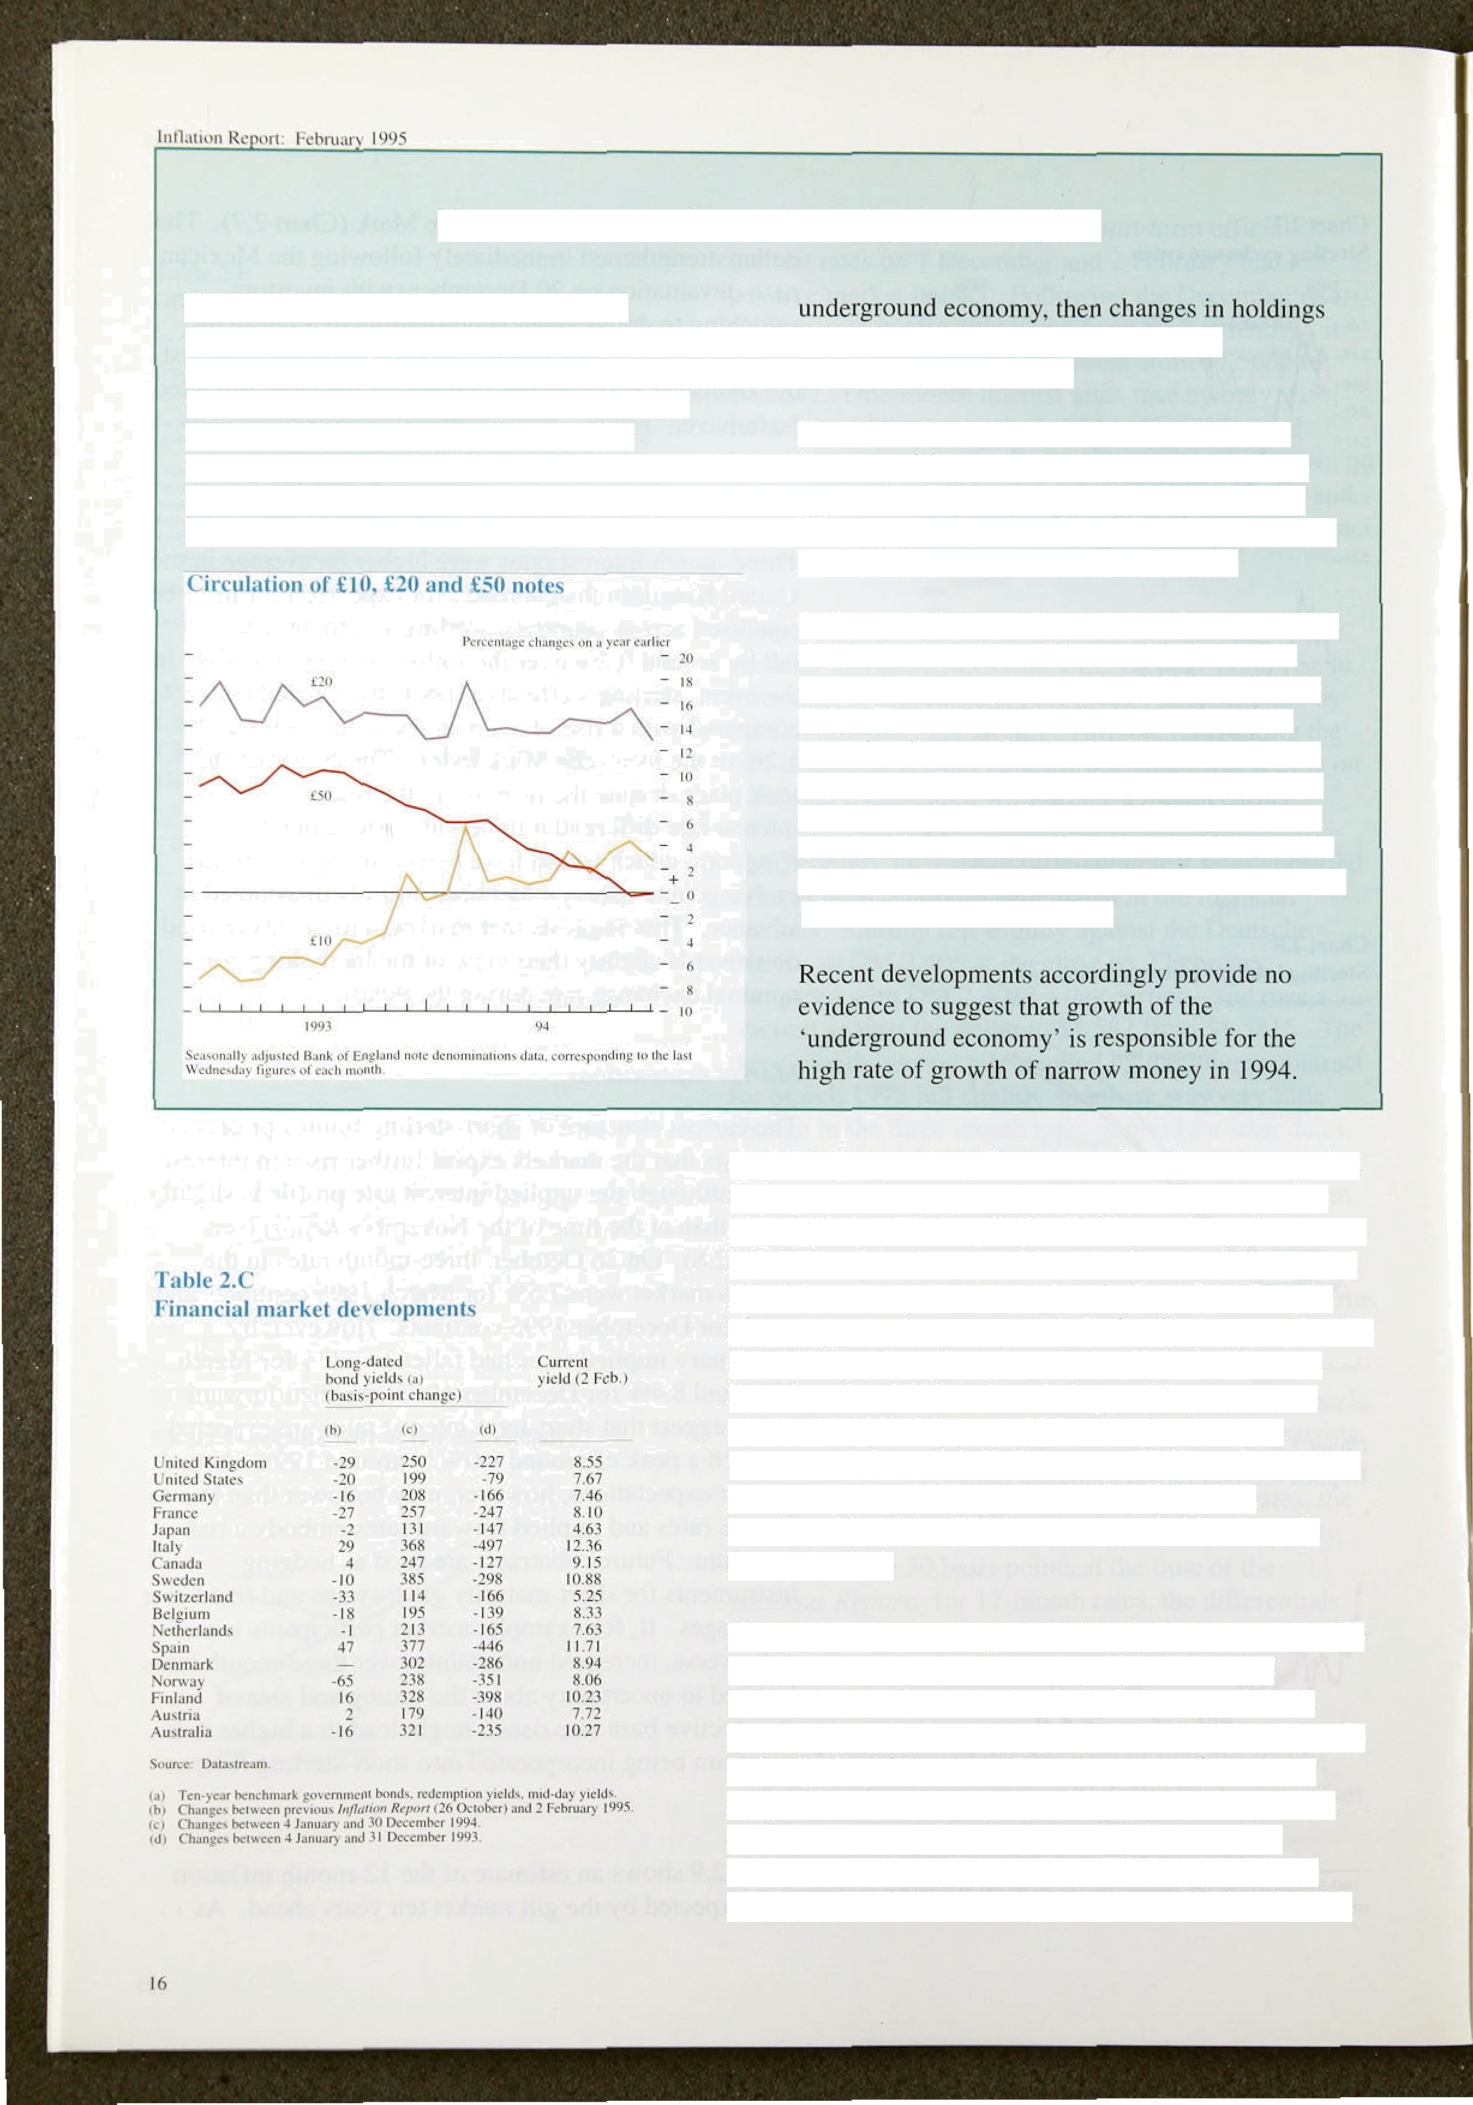

explained in previous *Reports,* such estimates may also incorporate a varying inflation risk premium and are approximate. The implied volatility on long gilt futures has fallen since August 1994, which may have reduced the risk premium in conventional gilt yields. But the chart suggests that expected inflation is almost as low as it has been at any time since index-linked gilts were introduced in 1981 and made it possible to measure expectations in this way. If these estimates are a measure of the anti-inflationary credibility of monetary policy, it appears that the credibility lost when membership of the **ERM** was suspended has largely been regained.

The markets entered a period of turbulence after the US interest rate rise on 4 February 1994. Table 2.C illustrates that the countries with the largest rises in

ten-year government bond prlces in 1993—for eKample Italy, Spain, Finland and Norway—experienced the largest falls in 1994. Chart 2.10 shows that there is a positive cross-sectional relationship between the movements in bond yields since Febniary 1994 and average annual inflation rates between 1984 and 1994.



**Chart 2.10**

Aletd etc:inges ana infIation‹•›



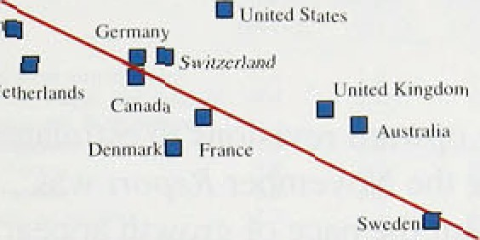



- fiusiniiiaR - 3.80

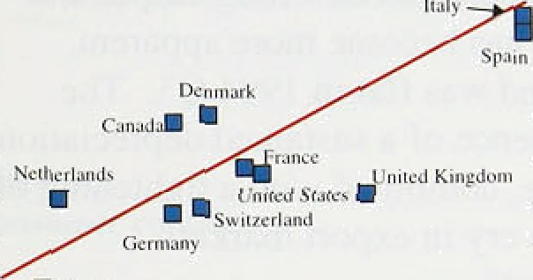

”

340

- 140





' SOlid liqe ! ndicams gignifi anci siutiatical relaliopnship.

'taj '' Basiâpoini.cttaagcc in.long bofl'a:jiclds.'in' l'993.arid 1994: j;cn-year



Not surprisingly, an economy’s past experience of inflation appears to have been an important determinant of inflation expectations.

International bond markets stabilised towards the end of 1994. UK gilts have risen in price and outperformed several other government bond markets since the November *Report.* In particular, the spread of ten-year gilt yields over .US .and German equivalents has narrowed, by nine and 13 I basis points respectively.

### z 3 S ar

Broad money growth remained subdued in the fourth quarter. Credit growth, however, picked units

12-month growth rate was 4.6% in December, up from 3.7% in Se tember. M0 continues to grow above its 07s—4% monitoring range. but, as expected, has recently been slowing down.

Financial market developments have given encouraging signals about the .credibility of UK monetary policy.

The lshort-term interest rates implied by futures markets have fallen since the November *Report,* though they still indicate that further rises in interest rates are expected. International bond markets stabilised towards the end of 1994. UK gilt yields have fallen in the past three months and outperformed several other bond markets.

Against a volatile international background, sterling has remained relatively stable.

 

3

L'hart 1.1

Res isions t‹i €iDP at 1990 factor cost

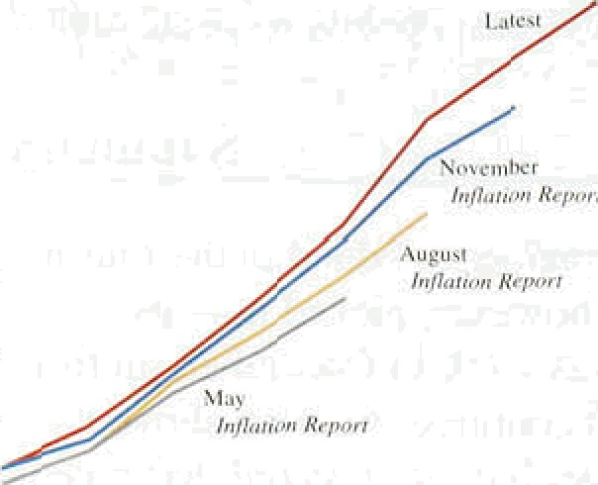



Revisions t‹i domestic **demand al 19911**

marker i rices



There have been further upward revisions to estimates of real output in 1994 since the November be *pârt* was published (Chart 3.1). But the pace of growth appears to have slackened—output grew at an annualised rate of just over 3&a in the second half of the year, compared with well over 4% in the ffrst. Although estimates of domestic demand have also been.revise‹i upwards

(Chart 3.2), the divergence between strong output and

weak domestic demand has become more apparent. Indeed, domestic demand was flat in .1994 Q3. The divergence is a consequence of a sustai!ned depreciation. in the real exchange. rate,. combined with a tightening. of fiscal policy and a recovery .in export markets.

## 3.1 Domestic demand

Real domestic demand increased by 2.She iii the year to 1994 Q3. Nominal domestic demand increased by 5,0%.

« Growth in every major component of private sector domestic dem;ind was less in the third quarter of 1994

'" than on average in the recovery up to that date (Table 3.A).

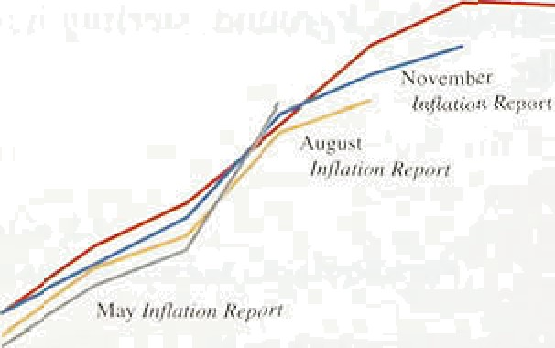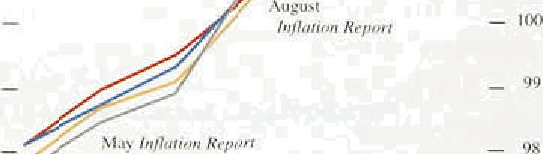

„

!003 Q4’

**Table 3.A**

Real CDP and **domestic** demand

Percentiigc quarterly changes: 1990 martei prices

1994 Q3 1994 Q4



Siockboildiug taj •0.3

Dom,Gcdomand -=



nmimd •› 0:9



I.992.Qf@4 Q2

average

0.3

0:6’

0.2

*Consumption*

Personal sector consumption growth slowed in the fi!rst three quarters of 1994 to an.average. quarterly rate of 0.4%. This compares with an average rate of 0.8to .in 1993. Tax .increases and the uncertainty about employment prospects reflected .in survey evidence (see: Section 4) were .the main factors behind the slowdown. In 1994 Q3, spending on .services spearheaded the 0.59•1 increase in personal consumption. Retail sales volumes increased by 0.5U in the !fourth quarter, compared.with 0.8% in the.,th.ird. Much of the1..increase came th



December;

sttong.

what they expecteed1l.. n:Deeem.

**Ofitil**

ta Rcrceniagr eoninbuIion:to. £iDP.

38

0.8.

0.:7



The CBI DIstfi§utive’Trañes S!urvey alsp’found that

.retailer expected.sales in.January to Se shgiitly ‘below normal for the time of year. **Ac'cordifig** to data Released:

,!by lire. British Retail Conaortiumaod:Touche.Ross,



**Tâblé SN**

Persohal **disposable** Income at:current pricm

###### non-,food sales in the first three weeks of January were little changed from those a year earlier.

of



income:learn employment -0,4 1,0. 3.)



-0.4

'/.9.

3,2

.s4:

###### future, as well as current, real income. This means it

.tends to fluctuate less than real personal disposable

###### s.5 income, which fell by 0.7% in 1994 Q2, but rose by

.sk l.59« in 1994 Q3 (TabJe 3.B). Recent Galiup surveys of

UK taxes on iocoote 2.3 4.4 6.8

SoCial security ce.nuibotionx 2.2 -0.3 8;.9

cpiricil tax:ppymznts 7..5 7.5

Ofh•r ded«clions ?.4 -I 4 9.4

7.0

-0.3

consumer confidence have shown no clear trend (Chart 3.3). In the period from November to January,

###### ci the balance of respondents expecting the general



i.s economic situation to improve in the next year was close

Memo: saving rniie (per centl .9.d *to,›* to its long-run average. However. the balance expecting

taj pal peoonaldisJ8ble iamme revalued by the iuiplied'consvrrrs’ ezpcndiiurc .their household’s financial position to improve was

‘’ below its long-run average. Consumers are, therefore, likely to remain cautious about their real income growth in the short term and to save most of any increase in

**Chart 3.3**

Cooauraer confidence



- - 30’



.'(aj' ponxe!‹o.;z 9ufsiion:oi.firmncial siiusiioa of ieipotulent’s household ts) flux 'lo'o.§uesiion on gtacral economic '*itnziion:omr.ihc next y' c.



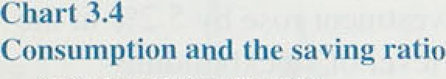



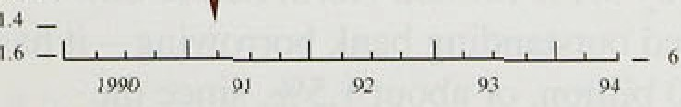

disposable income (Chart 3.4).

###### The housing market has been affected by the factors restraining personal consumptlon. Turnover, as measured by particulars delivered, is subdued; as a proportion of the owner-occupied housing stock, it is now about 25a lower than in 1980. Activity in the new homes sector is more buoyant: housing starts and completions both appear to be on an upward trend (Chart 3.5).

In January, house prices were 0.4% above their level a year earlier on the Halifax Building Society’s index.

Second-hand house prices have been more volatile than new house prices (Chart 3.6). In the early 1990s, second-hand house prices were depressed by distress selling and by sales of possessed properties. More recently, they have increased more rapidly than new house prices, partly because there have been fewer possessed properties on the market. The stock of

possessed properties held by lenders fell to 29,400 in the second.half of 1994, from a peak of 67,400 in the second. half of 1991; 24,200 properties were taken.into possession. The Nationwide Building Society’s seasonally adjusted index shows that prices were 0.5&• tower than a year earlier.

The.Bañk.estimates that negative equity amounted to around £fi bdl.ion.in:the.fourth quarter.of 1994,.some **J}.!/t bjJJjon** lest than a. **year** earlier (based on non

###### seasonal1y:adjusted regional.house price indices from the Halifax Building Society), .nround 1.'f•1million





tlomslng rniirkel activity

households were affected. The figures suggest that negative equity was higher than in the third quarter, but.

””'- , › this was .largely the result of the nornal seasonal fall in

* i‹• house prices. Estimates of negative equity are sensitive

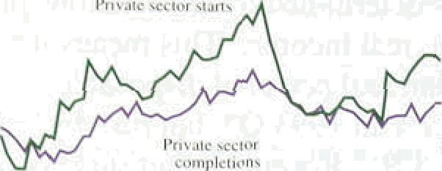

* '• to the particular measure of ho,use prices chosen.

"’ Approximately 250,000 mortgages were more than

_ ' six months in arrears at..the end of 199Mabout 2i!/i% of

_ outstanding mortgages.

— i• In recent years, potential first-time buyers have become " more cautious because of reductions in MIRAs tax relief,

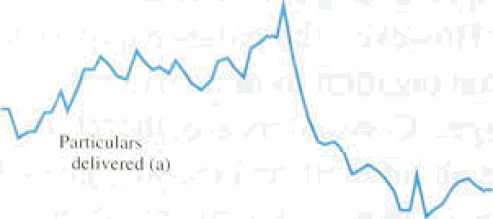' “"— • changes in income support rules and greater perceived "' job insecurity. Demographics have also had an impact,

reducing the size of the relevant age group. Hence an

i : increase in.turnover and house price inflation to the

_ “"'“"’ _ „ levels seen in the mid and late l980s should not be

_ „ expected.

"' *Itii!e.itrueiil.*

Total investment was slightly lower as a share of GDP in the third quarter than at the trough of the recession, although there are signs of strength in some sectors.

Manufacturing investment has tended to fall as a share of manufacturing.output through the recovery, as it did in the previous one (Chart 3.7).

- 30

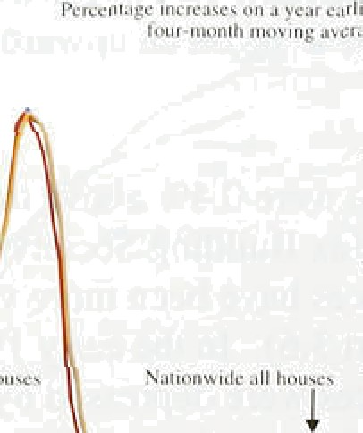

- 3{›

- ?0

lay H«Jir x »niJ N»‹1onwjdc Building 6ucioiy..prin indices {uno0jusie4T.

In real terms, total inve5tment fell by 1.6% in the second quaner of 1994 and by 0.69• in Q3. This offset a rise of 2.3% in Q1. In the year to the third quarter, it increased by 2.2&o (Table 3.C). The subdued state of the housing market was reflected in a fall of l.39c in .investment in dwellings, This. coupled with a fall in investment in oil and gas extraction, masked relative strength in other sectors. .If dwellings, oil and gas extraction are excluded, private sector investment rose by 5.29n in the year to 1994 Q3. A .lower level of stockbuildi'ng restrained growth in 1994 Q3, after making:a positive contribution in the first two quarters.,

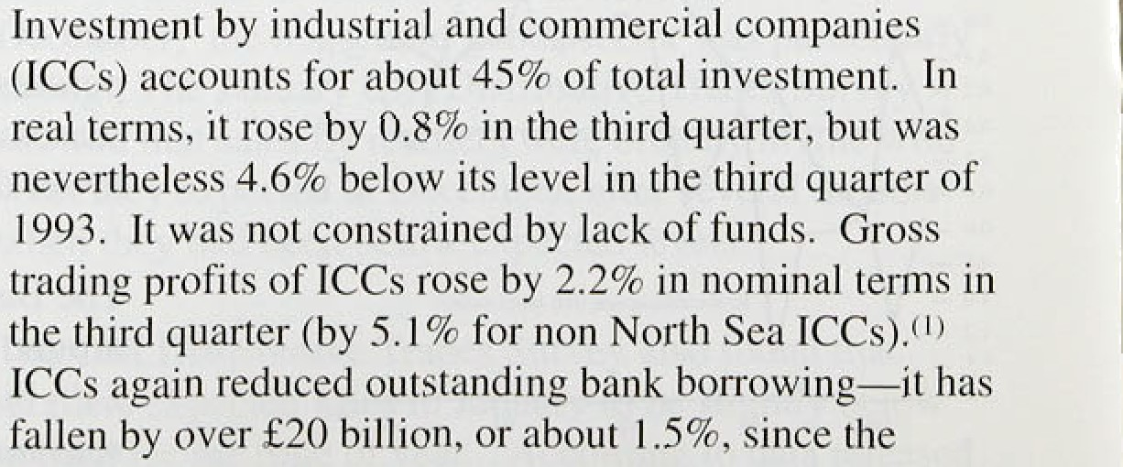





**chart.3.7**

**lovestroeat as a share..uf output**



trough of the recession.(' ICCs recorded a financial surplus of £2.7 billion or 1.9& of GDP, the fifth consecutive quanerly surplus (Chart 3.8).



— Teiet



120



The commercial property market is moving slowly out of recession, although a recent CBI survey .reported that

.demand for commercial property is not increasing as rapidly as activity, and that a third of large corporations expeclt to reduce their property holdings in the first half of 1995. Rents for prime sites are beginning to recoVer, but there is little sign of any general increase in rents.





8 7 ’6. 5. 4 J 2 l’0’1 .2 3 d ’5 4 7 B 9 10



Tabie 3.C

**Gross domestic fixed capital formation**

Perceniage!c0nuibiiiions.to tot investment proWtb

in yggF .‹a penal



Mining and qtiarryittg



*Government .iyendiiiy*

General government current expenditure rose by 0.39r in real terms in the third quarter of 1994. This was much in line with the increases seen in the recovery so far, but a little above what had been expected, as lower inflation increased the real spending permitted by the Control Total (public spending net of cyclical social security. debt interest and accounting adjustments). Central government increased spending most; local government

Manufaciuring



IYensfcre of existing land and-buiktings Total nen•residenfiiit *of* 'his/›:

*P-rifinte sector 'P.*fi6fic *,reclysr*

Dwelling,s



-0,â 0.2 0.2

-0.1 -0.7. -1.0



0.9. 0.4 —

1,1 3.'7 2.5

-0.9 *3.9* 2.2



current spending remained extremely subdued. Public sector investment—which is often volatile—rose by 12&o in 1994 Q3. and was 7.0% above its 1993 Q3 level. The public sector borrowing requirement (PSBR) between April and December 1994 was £23.3 billion, dowii from £31.4 billion in the same period of 1993/94.

**Chart 3.8**

**Corporate sector financial balance**

The Budget presented on 29 November confirmed the path of fiscal consolidation laid out in previous Budgets. The PSBR is now expected to fall more sharply than forecast in November 1993, because of stronger than

i‹ anticipated activity and lower than anticipated inflation. i• It is projected to be £21 '/ billion (3% of GDP) in



1995/96. This will require a 0.8& cut in real terms in '° lthe Control Total.

# Net external trade

With domestic demand restrained, net external trade accounted for all the growth in output in the third quarter of **1954** (Table 3.A). From the start of the recovery to the end of 1993, growth had been driven by domestic demând. In 19'94, demand shifted from



foreigh-produced to UK-produced traded goods in both ioreigh and domestic markets. Export volumes rose by





traacactions.cc.cvuntreported. hen.oootñin)e.a.largi.halanciig iiem:.

]nfIalit›n Rejxm: Fehru¿ar}'l 99a _

Chart 3.9

Export market shares›



**Chart J. 10**

— 11 2

growth was only about 1% (Chart 3.9). Import volumes fell by 0.3%, althoughl domestic demand was fla(. This shift occurred despite a further estimated loss in cost competitiveness. If manufacturing unit labo,ur costs are used to measure competitiveness, the United Kingdom has lost a little more than half:of the competitiveness gained against the six major overseas economies in the third quarter of 1992 (Chart 3,10). Relative producer prices, which are more timely, show that the United Kingdom has only lost a little competitiveness since the period following sterling's suspension from the exchange rate mechanism. It has .improved slightly against Japan. and more against European countries, such as Germany and France.

The strong eKport performance in the third quarter of 1994 narrowed the visible trade deficit from £2.4 billion in .Q2 to £1.6 billion in Q3. Together with an improvement in the invisible balance, this produced the first current account surplus since early 1987

(Table 3.D). In October 1994, the trade deficit widened

**Relative demand and cosM and the trade halance**

Re l ui inc dc mend

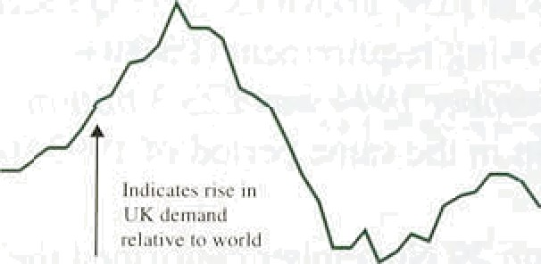



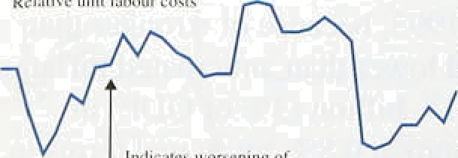

— +0

- 70

frtdicaieñ widenJ ng

sli from £0.5 billion to £0,.6 billion, but this was largely accounted for by oil and erratic items. Ezport volumes excluding oi1 and erratics gfew at an .annual rate of 30% in the three months to October compared with the previous three months; import volumes increased by 10&o., More timely data are available on trade with countries outside the European Union. These

suggest that import volume growth has picked up. In the fourth quarter, export volumes excluding oil and erratics rose at an annualised rate of I 3%, while import volumes grew .by 28%.



Prospects for export market.growth remain good. Domestic demand .in the OECD region 1s expected to grow as rapidly in 1995 as in .1994. In Europe as a whole and in Japan, domestic demand growth is

###### expected to pick up as their recoveries continue.(1) Only

.in the United States is domestic d'emand growth expected to slow.

1. 3 **Business confidence**

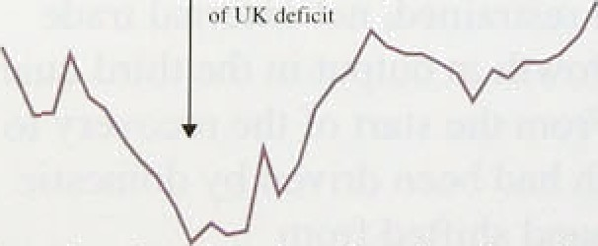

— 3.



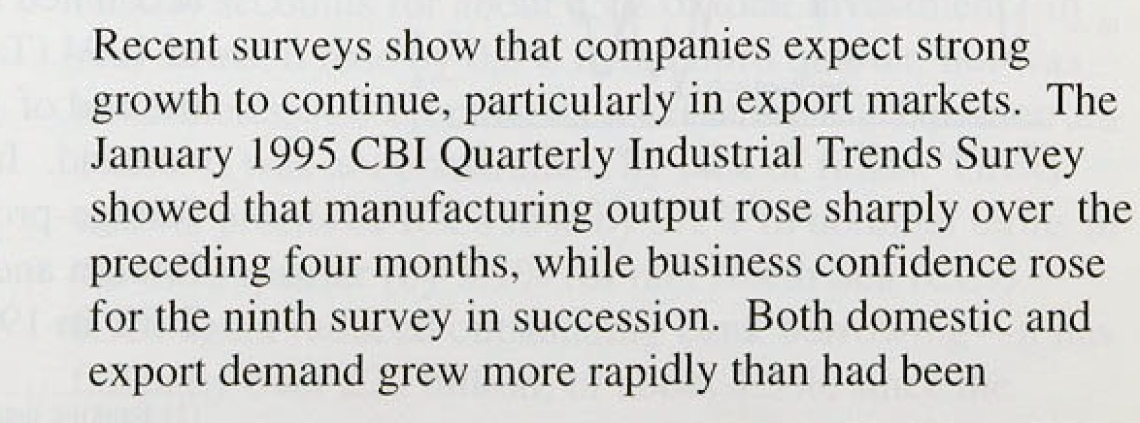





**Tañle '3:D Ext.ernal accounts**





Ohio :N De.c.

expected; and.the number of firms reporting working

.below capacity fell to the lowest level seen since July 1990 (Chart 3.11). The Chartered Institute of Purchasing and Supply reported in January that the

manufacturing econom y continued to expand, but that



visibe balance

exC)\idi0g On

-3.O -2.4 -.1.6 -0:6 —



growth was slowing. Increasing delivery times from suppliers indicate the existence of capacity constraints.

Quarterly

erratic it¿rtjs -4,2 -4:1 -3.0 -0.9



invisible balance I.5 1.3 2 4 —





**Chart 5.It**

**CBI capacity** utilisation •›



**Ciiart 3:12**

**.Business eonfidence*•**

The.British Chambers of Commerce

* Economic Survey reported in January that the balance of
* manufacturing exporters enjoying increasing orders was

the highest since the Survey began in 1985. Sales and deliveries in the domestic market also continued to increase, but.the Survey reported that the impact of interest rate increases was being felt. Capacity utilisation in manufacturing was reported to be at its highest level for five years—a picture confirmed by other surveys which identified supply constraints in a

* • number of sectors, such as chemicals.
  + Companies are becoming less positive about future investment. Both the **CBI** and the Chambers of
  + Commerce found that investment intentions were

, marginally less buoyant than previously reported, despite

_ evidence that capacity utilisation in manufacturing has

, reached levels last seen at the peak of the previous cycle. Respondents to the **CBI** Survey said any investment was

›• undertaken to increase efficiency and not to expand capacity; uncertainty about demand was the main factor

* + dampening investment plans (Chart 3.12).

3 4 O t t

Output is now thought to have risen by 0.8&o in the third quarter of 1994, and by 4.1% in the year to the third quarter (Table 3.A). These increases were previously estimated to have been 0.7&o and 3.6% respectively.

Non North Sea output also rose by 0.8% in 1994 Q3,

.giving a four-quarter growth rate of 3.6%. Preliminary estimates indicate that output grew by another 0.89c in the fourth quarter of 1994. In nominal terms, output increased by 1.5% in 1994 Q3, and by 5.7% in the year to Q3.

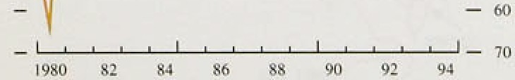National Accounts ldata show that all the main components of output (with the exception of construction) grew robustly in the third quarter, with

##### ;manufacturing output,rising by t.2&o and total services output.increasing.by 0:8& (Table 3.E). Output .is now

.iñgñer.than its previous peak.in.all sectors except

Construction and maiiufscturing„ It was surprising that

Inflation Reports Februdfyl 995 _

Talile 3.E

Output components ‹›f t•DP at 1990 factor cost

WciyhLs ‹:›\ Quarterly Puur-quarter



provisional data for November indicated that industrial production fell by 1.0&o in the month; part of this was due to a fall in electricity outPut brought about by gond weather, but manufacturing output fell by 0.79•—the largest monthly .fall since June 1993—despite strong

labour demand in the sector.



Prodt1ctiun



72 1. I - I.3 3.7 2.3

2¥I 2.2 I.3 6.0 5.9



Output growth was slower in the second half of 1994 than in the first. But it was still higher than the rate at which output can grow in the long run without adverse inflationary consequences; the ‘output !gap’ continued

to close. Output growth will have to slow down to a.rate. consistent with the accumulation of capital, labour force growth and innovation. In the past, this has been in the range of 2&•—2'/i9r a year. At the moment, however, there is still some spare capacity (particularly in sectors catering primarily to domestic demand).

### 5 S

Revisions to data raised the estimated profile of activity in the first three quarters of 1994, but confirmed that growth slowed in the second half of the year. They also showed a substantial divergence between domestic and net external demand. The preliminary output estimate for the fourth quarter of 1994 ihdicated that output growth, although slower, continued to be above trend. Capacity constraints are becoming more widespread in industry. Even if the recovery continues at the pace seen in the second half of 1994, supply constraints will intensify. This will increase inflationary risks unless productive capacity increases.

 

**Chsrt 4.1**

**•Underlying’ earnings 8rowtti'•'**

Greene+gc chsngcs en a year oarli

I0





4.1

Earnin S

Whole economy underlying earnings rose by 3’/•9o in the year to November, unchanged from October. Within the total, underlying manufacturing earnings increased at a 12-month rate of 4'/•&a: this was unchanged from the previous month, but up from 4'/ % in August. In the service sector, underlying earnings growth fell from 3'/*ho in September to 3'/•% in November (see

Chart .4.1).

.|g0;l ’92’ ’93 9’

Table 4:A

**Earnings and settlements**

.*Preyinuc'nioiitfUqrorter* iii frolics

W8g>S and salaries per head’ Q3



,eanii\mgs (Greitt Bnain) Noy.

3’.5

12



3.9



*3.0*

There is no official measure of pay settlements, but survey evidence suggests that settlements have increased slightly since the time of the November *Report* (see Table 4.A). According to the Industrial Relations Services survey, for example, average settlements were around 2.59r in the first three quarters of 1994. but increased to 3&o in the last three months of the year.

Around a quarter of all wage agreements have January implementation dates, however, and it is not yet clear whether settlements are about to increase. Early indications are mixed. The IRS suggested that a higher level of settlements was being maintained in 1995; the CBI Pay Databank showed pay awards starting to ease

iDS:ta› . Jan.: .3:0'-3.9



3w

3.0



**Cli:Art 4.2**

**Nominal wage lnDation anti uneiiiploymefit**

rat•





###### *3.0* towards the turn of the year.

Z.9



Historical experience suggests that the current behaviour



of wages is not unusual for this stage of the business cycle. In the past, wages growth has remained relatively steady for long periods while unemployment has been changing rapidly. In the mid 1980s, for example, wage inflation rose by less than three percentage points while unemployment fell by five percentage points. Similarly. between 1990 and 1992 unemployment rose by four percentage points and nominal wage .inflation fell by around two percentage points. But that does not necessarily imply that wages growth will remain

.subdued. Wages growth can increase suddenly with

li:ttle movement in the unemployment total. Chart 4.2

,shows that, in tS79 alone, nominal wage inflation

**picked** up.by’ almost ten percentage points.

##### ‹ Any iiicre se in nomiñal wages!dep.ends on both.the.real



* + - wage and .the inflation expected b,y wage..bargainers n both sides.of the table.’ .What wi11liappen to the real



L**aiion Report: Febru 1995

##### wage? The target real wage depends upon the degree *af*

.labour market tightness, productivity increases and the structure af the.labour market.

### 4.2 Labour demand

There is clear evidence that the demand for labour is increasing. Employment has risen on both official measures. The workforce-in-employment series, which is based on a survey of employers, increased by 140,000 in the third quarter. The Labour Force Survey (LFS), which is based on self-assessment of hours worked, has consistently recorded.an increase in.employment since the spring of **1993.**

Despite the convergence of the two indicators of labour demand in recent months, the LFS continues to show greater job creation since the trough in employment.

According to the autumn 1994 Survey, total employment. increased by 408,000 between winter 1992/93 and autumn 1994. In comparison, the employer-based survey recorded a 66,000 rise in,total (GB) employment

between December 1992 and September 1994. One explanation for the discrepancy is that the LFS is faster at recording jobs created by new businesses. It 1s also possible that the workforce-in-employment series is depressed as a result of companies neglecting to declare jobs involving short-term contracts. If so, the LPS would provide a more accurate measure of demand conditions.

One way of adjusti!ng for.the number of part-time jobs when assessing the aggregate demand for labour is to consider the overall number of hours worked. According to the LPS, aggregate hours worked in the whole economy rose by around 1.4% between the summer of 1993 and the summer of 1994. This supports the picture of increasing demand for labour. Evidence of a tighter labour market can also be seem fn the,sp1it between

full-time and part-time,jobs. In 1993, all of the.netjob

,creation was in part-time work, whereas between lthe spring,and autumn 1of 1994 f\il1!-time jobs accounted for

.65% of total employment grow,th.

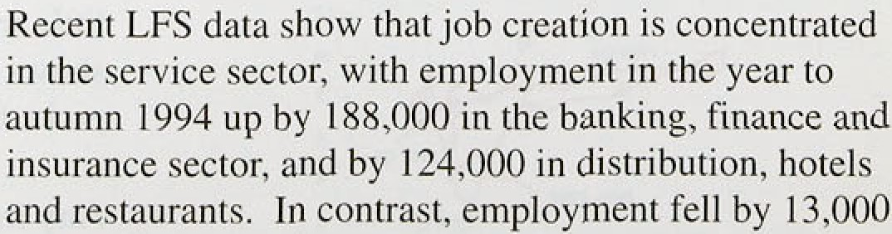



**.Chart 4.3**

**Falls in unemployménti recoveries compared**

- jO

+

' -.’ 0’

-•30

smaller manufacturing firms. For .example, the January CBI Quarterly Industrial Trends Survey noted that manufacturers expected .almost no job losses over the next four months—the most positive outlook for jobs since April 1989—and firms with fewer than 500 staff expected to take on workers. This is consistent with strong demand for UK exports. Nevertheless, if

competition in the retail sector continues to intensify,

this would lead to job-shedding among larger retailers in

1995.

The dichotomy between the tradable and non-tradable sectors of the economy could. other things being equal, drive up real earnings for any given level of unemployment. This would happen if the reallocation of resources from job-shedding to job-creating sectors of the economy was slow, leading to skill shortages and greater pay differentials between the sectors. However, the decline in manufacturing employment since 1979 may mean that the skills needed to meet the demand for tradable goods will be available among the unemployed and workers in other sectors. The January CBI

Quarterly Industrial Trends Survey reported that 109 of firms expected their output to be limited by a lack of skilled labour, compared with 28% when the series peaked in October 1988.

### 4 3 Une l e t

Claimant unemployment fell by 54,600 in December, after declining by 45,900 in November and 48,400 in October. Over the three months, the average monthly drop in the number of people claiming benefit was 49,600. This compares with 38,300 over the six months to December and 29,800 over the year as a whole. Unemployment according to the internationally-standard International Labour Office

definition has also fallen sharply. It was down 144.000 in the three months to November—and has shown .a similar profile to the claimant count since unemployment started to decline.

Unemployment is falling much earlier in the present

###### output recovery than in previous recoveries. But the size

.of scent falls in the number of claimants is not out of

line th:those seen at a similar stage of the previous

###### .Unemployment cycle (see Chart 4.3). Comparisons with

' the 1980s are complicated by the i'ntmduction of the Restart ) progr.ainme.in 1986, but this phenomenon, taken:at face. v:a1ue, may be a consequence of the







deregulation of the lnbour marke!. If firms: found it easier to hire and fire, that would bring forward any declines in the claimant count.



Ithin of wocancies lo unemployment

# 4.4 Alternative measures of labour market

htness

The interpretation of each labour market .indicator is fraught with difficulty. Not only have different measures. of labour demand sometimes shown contrasting patterns, the claimant count depends on the tax structure, eligibility rules and the efficiency of Job Centres as well as on the state of the labour market. There are, however,

, other measures of labour market tightness. These

" include vacancies and inactivity rates.

- 10



The number of vacancies advertised at Job Centres was flat in December, after rising strongly in October and November. Vacancies tend to rise as a proportion of unemployment as output streng.thens. Chart 4.4 shows that the ratio of unfilled vacancies to total unemployment stood at 7.5% in December, its highest level since January 1991. However, it remained significantly below the peak of 13.1% reached in 1989.

Inactivity rates the proportlon of people .of working age not employed—can also be used to assess the tighmess

of the labour market. Inactivity would be a good guide to the state of the labour market if there werel many people out of work who would start looking for a job if they thought that the demand for labour had increased. This was the ease in the inid 1980s, for Instance, when all o( the net jobs .created in the recovery were taken,by women who joined the labour force. However, if du’ring the recession pf the early l990s some 'discouraged’ workers entered full-time #‹iucation or took early retirement, this could mean that fewer woulñ be available to be abs:orbed:quickly imo jobs. In this:case, inactivity rates would overestimate .the degree of slack in

:the labour .market.

.But. what are.the various i!ndieators telling us about the.. degree of labour market tightness at,t1ie.moment* Do ley suggest that.wage are about to accelerate.* Job creation and falling unempiciytñent threaten upwud

.pressure on real wages,if they mean! that!emp1oyees feel

.more secure, in! their jobs.and.push more.aggressively for, pay increases, and employers resist less because t1iey.are eager to..!retain experienced.„workers. Pay will.rose if the jobless total is pushed beloW the 'natural.' rate of unemployment—the rate oJ unemployment consistent





**Chart 4s.**

**Unemployzaent and vacancies**















- 0.b

gp

- I.2

###### with stable inflation given the stance of monetary policy. Iflthis happens, upward pressure is exerted on costs, adding to the pressure for firms to charge more for their goods.

One way to gauge the degree of tightness in the labour market is to compare each indicator with its historical average. However, this ignores the fact that periods of high unemployment lead to skill erosion and demoralisation among people out of work, particularly the long-term unem ed, removing some from the pool of labour actively competing for jobs. Although demoralisation may be reversed if labour demand increases for a sustained period, skills may be lost permanently. implying that the level of unemployment which is consistent with stable inflation changes over



###### time.

120 1f0 40 0 40 80 1 20











An alternative method, which acknowledges that the number of people actively looking for work changes over time, is to compare the various indicators with a more recent trend in unemployment. Using a moving average of the past eight years as a rough guide to what is happening to the natural rate of unemployment suggests that some slack remains in the labour market. Chart 4.5 shows the gap between the actual level of unemployment and its moving average against the gap between the actual number of vacancies and their moving average. It suggests that although some slack is left in the labour market it is fast being eroded. There are, of course, other methods of estimating the levels of unemployment and vacancies consistent with stable inflation.

A comparison of the inactivity rate with its eight-year trend suggests a much greater degree of slack. Chart 4.6 shows that inactivity remains significantly above trend. Taken at face value, this would imply that downward pressure on real wages should continue for some time.

However, for reasons outlined above, it is likely to exaggerate the degree of slack. The true degree of labour inarket slack probably lies somewhere between the estimates derived from unemployment and inactivity data, suggesting that real wages are unlikely to pick up shayp!y in the near.future. It is also possible: that a given

###### .degree of tightness in the laborer market will now:exert less upward pressure on real wages than it has in the past,:for example, because lower perceived job security could tower.the real wage'targeted by employees.

Jo how secure do workers feel: in their jobs? Falls in the



"” .ânempl:iyment count would img!y greaterjob security if

? , ’ .29'



deregulation of the labour market. If firms found it easier to hire and fire, that would bring forward any declines in the claimant count.

# 4.4 Alternative measures of labour ma.rkelf

t ht ess

###### The interpretation of each labour market indicator is fraught with difficulty. Not only have different measures of labour demand sometimes shown contrasting patterns, the claimant count depends on the tax structure, eligibility rules and the efficiency of Job Centres as well as on the state of the labour market. There are. however, other measures of labour market tightness. These

" include vacancies and inactivity rates.

— — 6



###### The number of vacancies advertised at.Job Centres was flat in December, after rising strongly in October and November. Vacancies tend to rise as a proporhon of unemployment as output strengthens. Chan 4.4 shows that the ratio o( unfilled vacancies to total unemployment stood at 7.5% in December, its highest level since January 199 l. However, it remained significantly below the peak of 13.19o reached .in 1989.

Inactivity rates—the proportion of people of working age not employed—can also be used to assess the tightness

of the labour market. Inactivity would be a,good guide to the state of the labour market if there were many people out of work who would start looking for a job if they thought that the demand for labour had increased.. This was the case in the infd 1980s, for instance„ when all,of the net jobs created in the recovery werel taken by women who joined the labour force. However, if during the recession of the early 199,0s some 'discouraged’ workers entered full-time education or took early! re.tirement, this. could mean that fewer would.be available to be: absorbed quickly into,joñs. In this'case, inactivity rates would overestiiriate the::‹iegree of slack in the labour market,

But .what are.the various ind!icators. telling Its about the. degree of labour market.tightness at the moment? Do they suggest that wages are about to accelerate? ’Job

. creation d falling.'unemployment threatefi upward’ pressure on re.a1 wages ifi they myan that emp1'oyees feel more secure in their:jobs ’and.push more aggressively for pay ncreases, and employers resist.less,.becaqse they are, eager to retain.!expeneneed workers. .Pay will,rise if ihe. jobless ,total .is pushed below the ‘natural' mte of unemployment the rate of unemployment consistent

,28



**Chart4J.**

**Unemployment and vacancies**

 



 

87QI







120 fitl 411 0 40 80 l Al

(W l U eIUKwenip1oymenlmius*ghyeunmwng





: :i''na't•'nnis o:, resniao isss

###### with stable inflation given the stance of monetary policy. lf this happens, upward pressure is exerted on costs, adding to the pressure for firms to charge more for their goods.

.One.way to gauge the degree of tightness in the labour

.market is to compare each indicator with its historical average. However, this ignores the faci that periods of high unemployment lead to skill erosion and demoralisation among people out of work, particularly the long-term unemployed, removing some from the pool of labour actively competing for jobs. Although demoralisation may be reversed if labour demand increases for a sustained period. skills may be lost permanently, implying that the level of unemployment which is consistent with stable inflation changes over time.

An alternative method, which acknowledges that the number of people actively looking for work changes over time, is to compare the various indicators with a more recent trend in unemployment. Using a moving

###### - ---- of the past eight years as a rough guide to what ring to the natural rate of unemployment

that some slack remains in the labour market.

###### i shows the gap between the actual level of

-yment and its moving average against the gap the actual number of vacancies and their average. It suggests that although some slack is e labour market it is fast being eroded. There

The following chart should replace Chart4.6

on page 29.

nurse, other methods of estimating the levels of iyment and vacancies consistent with stable

Nson of the inactivity rate with its eight-year

g ggests a much greater degree of slack. Chart 4.6 rat inactivity remains significantly above trend.

: face value, this would imply that downward

* on real wages should continue for some time. r, for reasons outlined above, it is likely to

" * ate the degree of slack. The true degree .of market slack probably lies somewhere between. mates derived from unemployment and inactivity



—

###### ;gesting that real wages are unlikely to pick up in the near future. It is also possible that a givefi jf tightness iñ the labour market will now exert card pressure on real wages than it has in the

.exSample, because lower.perceived job security

‹wer the real wage targeted by employees.

secure’do workers feel in their jobs* Falls in the

" ’. ” .nyment count would imply greater job security if





C’hart 4.7

¥i erage duration of' spells of unenipJo3'meiiti:'›





J’able 4.B

Redundancies per 1.000 employees by occupation

1991 1 09 1903 1994



iVfan«gtrs an+I

administrators I 2.8 I 2.4 10.0 ’?.0 7 9 9.9 8.0

Prot”essioncls 7.0 6.2 3.8 5.5 6.0 4.6 —. Technical 13.I IO.9 8.I — /i.'J 3.y 6.2

Clerical 14.2 t4.fi 10.4 8.0 9.1 7.7 6.2

SkilTedmanual 33.J *7.7 2l.3 l9.4 23.9 IR.I I7.6 AMO0BT¥eW'TCeS 9:H 6.9 7,0 5.7 — 5.7 ¿.4

Sales 16.6 14.'? 0.7 7.9 9. I IO.2 IO:4

Machine

opcmt›ves 30. I 22.6 1 5.3 i ›.3 IS.6 l6.I 3.4

Other l9.8 16.8 t4.2 13.k I 3.5 9.2 12.1



the likelihood of,any person becoming unemployed also declined. The longer the individual spells of unemployment for a given amount of overall unemployment, .the fewer people there are who will have experienced a period out of work. That is,.a longer average duration of unemployment implies greater job. security for those in ,work. However, the .series is distorted if unemployment is changing rapidly: if unemployment is rising, the average duration declines, merely because some people have just started .to sign on. It is possible to adjust for changes in unemployment.

Chart 4.7 shows that the ‘normalised’ measure of duration is rising sharply and is above the levels of the early 1980s. This suggests not only that security is increasing, but also that job insecurity in the recession of the early 1990s never reached tire lows of the late 1970s.

This of course does not explain th’e ‘feel bad’ .factor among employees. Survey evidence suggests that feelings of job insecurity have risen markedly. A study by Industrial Survey Research found, for example, that barely half of UK employees felt secure in their jobs at the end of 1994, compared with three quarters of workers between 1977 and 1987. One possibility is that the pattern of redundancies.changed between the early 1980s and early 1590s,”with a greater



redundancies al and professional workers. Unfortunately the data have been collected only since 1989, so it is .impossible to compare the two periods. Table 4.B ,suggests one explanation: .in the. present recovery, redundancies among managers and administrators .have .fallen from 12.8.9r in !199.l to 8.0% in summer 199 much less .than the decline.among other categories of worker.



The Bank's inflation projection assumes'that real wages will respond gradually ’to the tigliteni!ng of ihé liabour

.market. It also assumes that w.orkers! will,.attempt.to. shield themselves from:the effect.!of thé increase in indirect.taxes announced. in.the N.oxember.Budget:, that in .the short run, they wil!l be successfql, but tliat:i.n the. long run, workers wi!1i be unable. to protect themselves against tax rises. .Both these.effects feed through to noyiinai wa:ges only if in.Stationary .expectations ,do not fâll!.

# 5 Pro ti i and t bo



**:Table.4.C:**

Un!t wage costs.and,their components

Pñzcejiuige abanges.o/t'same pcnod:ui'prexipuB year

{'0.uipui. Employ- : Labour Earni»js.:per U*it wage





###### labour costs and productivity. The latest data for the: wiiole economy show that unit wage costs were flat in the third quarter, compared with the same quarter a year earlier. Manufacturing unit wage costs are falling according to a 12-month comparison (see Table 4.C). In

the year to November, unit wage costs in the

199L ?: -T ’0.7

1992 -05’’ -2.5 J:

19.93 ’2:1 -L2^ ’3.3

.8:0 7.3

6.3 4.2

3.6’ 0.J

4.7 0.7

3.8

3.2 0:4

###### manufacturing sector dropped by 0.89•. This followed a 1.8% fall in October, one of .the largest falls since records began, and a 1.5% decline in September.

0*. Z7 01



3.4 0.





3.6

2.9. g.2

4.J 0.9

3.5' -0.6

4.0. —

###### However, short-run .measures show that manufacturing unit wage costs reached a turning-point in July 1994: on a three-month annualised basis, they are now rising at

over 4& .

t99l -S.4 -8:0 l,2 8.2 7,0

t992' ’0’.6. H.2’ 4:5 6:6. T.9

t99’3 ’L3’’ ’3.4. ’ 3: 45 0.6



(j4 1.5 -.0:4' 2.0 4.0



1'4oié: Nianufaciuring cinploJeñt;aad.average earnings ore based on StC1980:



**Chart 4&**

**Whole econoiriy neul product wages in relation to productivityt•›**





Whol* eooifunJ a'iercgo.tariiings:divideii by:the jnce difieior. For GDP



###### The figures for productivity are based on emplo ment

data from the workforce-in-employment series. If

.Labour Force Survey data are used, whole economy unit wage costs rose by 0.69‹ in the third quarter compared with the same quarter a year earlier; they were flat in the second quarter. If the labour market continues to tighten, it is likely that unit wage costs will rise faster in 1995.

Real unit labour costs the share of national income

###### taken by labour—have also continued to fall and are now

.below their long-run average (see Chart 4.8). Productivity improvements across the economy have in the past tended to be captured by employees in higher wages, rather than resulting in lower prices. In the long run, if productivity grows at an annual rate of around 2'/2&O, workers cannot hope to secure wage gains of more than .5% a year without jeopardising the Government’s ability to keep inflation in the lower half of its ldc—4' o target band. The Bank’s inflation projection allows for some increase in pre-tax real wages, in line with the experience of the 1980s. It assumes, however, that the share of profits in national income will not be eroded as rapidly as in the 1960s and 1970s.

1. E e t ns

Expectations of future inflation are central to the outlook for nominal earnings. The December survey of price

.expectations from Gallup suggested that employees thought prices would increase by 4.5&• over the coming year, unchanged.from November. The December figure was i!n tine with the average for 1.993 and 1994: mflation expectations have remained steady over the past two yeari. Wage expectations were much more





 

Int1ejion Reyon: Fehniary 199°' _

C’hart I.9

Desired percentage increase in real wages over the next 12 m‹inths



- - 0.2

i 9 0 u I s* 93



###### subdued: they have remained around 2’/sha.over the past year and were.2.4% in December. A different pattern emerges if the Gallup data are adjusted, to show the desired real wage increase over the next 12 months. This dropped sharply after the suspension of sterling’s membership of the Exchange Rate Mechanism, and remained subdued throughout 1993. The desired increase rose in the first half of 1994, before falling back to around '/•9r in the fourth quarter (see Chart 4.9)., It rose slightly in January.

The outlook for nominal wages will also depend on whether wage bargainers react to any increase in mortgage interest rates by pressing harder for wage increases. This would.happen if bargainers .used the current level of headline RPI, instead of RPIX inflation, as the basis for their wage claims. The Bank’s projections assume that workers manage to reclaim half of the effect of higher mortgage interest payments in the shori run, but none in the long run.

47 S

###### The labour market is tightening rapidly. Some slack still remains, however, and this should continue to eKert downward pressure on real wages for some time to come. This effect is likely to be offset.in the short run by workers trying to protect their real wages from the effect of higher indirectlaxes introduced in the November Budget. In addition, there is a risk that any rise in nominal earnings growth will be exaggerated by the effect of the recent interest rate rise on retail price inflation. This would happen if wage.bargainers focused on RPI rather than RPIX inflation. Up to now., increases in nominal wages have not fed through to a higher

12-month inflation rate, because productivity increases have pushed flown unit labour costs. .Unit wage costs have already reached,a turning-point.

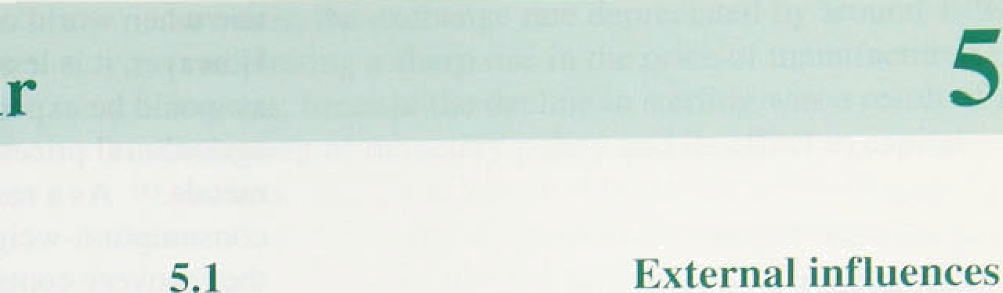

Chart 5.1

**.Sterling oil and non-oil commodity prices**

130:’—

I20.—



.tkfi-had:Haley

”1 ’t ’M’ I’M I’’J ’a ’S O 7T D J

After rising sharply in the first six months of the year, commodity prices showed little consistent pattern over the second half of 1994, although there were signs that

„ they started to increase towards the turn of the year (see

•• Chart 5.1). Non-oil commodity prices were 99c higher at

„ the end of January than they were at the time of the November *Report,* after dropping 6% in the previous two

" months. Crude oil prices ended January at roughly the g level they were three months earlier.

The Economist index of commodity prices has probably overestimated the cost pressures facing firms over the past year and hence the degree of inflationary pressure arising from raw materials. A consumption-weighted index of commodities would have shown a much flatter profile in 1994. ) There are two main reasons for this. First, a number of foods produced in the European Union are partially insulated from world price rises as a result



of the Common Agricultural Policy (CAP). This has not previously been taken into account. Second, currently available indices ignore production in the United Kingdom and, in particular, attach too great a weight to highly volatile metal prices. Preliminary work undertaken in the Bank suggests that a

consumption-weighted index is a better guide to manufacturers’ input prices; it is likely that the rise in the index over the past year has already fed through into input prices.

Looking ahead, are commodity prices likely to go up? Bank research suggests that non-oil commodity prices, as measured by the Economist index, tend to increase when world output is growing above trend. This is what is to be expected if it is expensive to store commodities and they are traded in competitive markets. But many

,coiniriodities cañ be easily stored. As a result, traders have to form a view about future price movements when **iiéciding** whether to buy or sell. So for these com;no1dities only *unexpected* increases in world demand will drive prices hfgher. .Preliminary work on the consumption-weighted index suggests that it too tends to





f nt1ati‹›n Rcyort: Fehn;«zy j Eq1 _ _

rise when !wor1d output is growing.above trend. However, it is less cyclical than the Economist index— as would be expected giv,en the irripact of the CAP on agricultural prices, and the lower weight attached to metals.(' As a result, it is likely that the

consumption-weighted index will climb a .little higher as the.recovery continues, although the extent of atiy rise— and its timing—is uncertain.

Charl

’l’he sterling **exchange rate and** non-nil







- 12



— 10



l9A2 &) tu b5 b6 B7 BR F9 O0 0} 9? 93 04

thart 5.ñ

**ftelative prices uf” domestic nnd imported**



Raiio of manufactured

— I05



*O»erxeas iii)’latioii and iin,port yrices*

Each of the seven major economies grew by around 1% in the third quarter, around the same .rate ,as in the second. It now seems likely that world activity will grow significantly faster in 1995 than foreseen at the time of the November Report. Unless this increase in activity is fully offset by higher world interest rates— which is unlikely in 1995, because of the lags in the

monetary transmission mechanism—it will lead to higher world prices. The extent to which foreign currency price increases feed through to domestic inflation .is determined by the exchange rate. If exchange rate movements offset the.difference between UK and foreign iriflation, overseas price increases will not affect UK inflation. In the long run, domestic inflation is determined by domestic monetary policy.

Past movements in sterling import prices have reflected

.changes in exchange rates closely (see Chart 5.2). Prices of non-oil imports rose by l7&• between 1992 Q3 and 1994 Q3. In the same period, ,the sterling effective exchange.rate depreciated by 13&•.

In the long run, the.prices of manufactured imports should move in line with the prices of domestically

###### .produced substitutes—the exchange rate should move to

.offset any difference between UK and overseas inflation rates. However,. since goods are..not!produced in

does not always hold in the short run.. In p cular, monetary policy shocks can affect relative prices. Chart 5.3 .shows how relative prices of manufactured imports and domestically produced!goods. have changed since 1988, and iI.lustrates how relative.prices.reacted to two sharp sterling depreciauons. In 1989, .sterling,:s effective



. exchanges..rate.dropped b:y,'1.2 : this. did not lead to an

s

###### be ause e.dep

a

###### ation refl fted th ed t a$ es of

goods were increasing more quickly in the United .

Kingdom:than.m JU main,competitors., When sterhngls

.membership of..the ERM wag, Suspended in 1993,





Chart 5.4





t9J0 72 74 76 7# 80 82 84 86 %S 9O 92 W

tel,' gie-ion tale of mourn on capiial stock n rcplzcemciii comm

Chart 5.5

**Producer price inflation**





- I2



however, the exchange rate depreciated by around 17%.

.precipitating a sharp rise in the price of manufactured

.i!mports, because the decline in sterling was a result of a loosening of monetary policy and its effect in capital markets.

2 tab t

Profits are growing strongly. In nominal terms, industrial and commercial companies’ (ICCs’) profits rose by 2.2% in the third quarter of 1994; they were up l4&o on a year earlier, and around 35% higher than at their trough in the third quarter of 1991. Profitability— the rate of return on capital—depends on how prices

.move relative to costs, and on the extent of capacity utilisation in the economy. Chart 5.4 shows how the strong growth in profitability in the current upturn is in line with previous recoveries, although it started from a higher level. However, whole economy rates of return mask starkly differing performances between different sectors. At the moment, for instance, sectoral rates of return are signalling clearly the need to reallocate resources away from retailing and into export-directed industry.

*Manufuctui ing*

The November *Report* noted that the cost of manufacturers’ materials and fuels had risen rapidly, and that the strong increase in input prices seen earlier in the year had begun to feed through to the prices of goods leaving factory gates. Up to that point, thanks to falling iifiit labour costs, manufacturers had been able to absorb most, if not all, of the rise in the cost of raw materials and fuels. .One uncertainty was whether more of the increase in material costs would be passed on to manufacturers’ customers.

Since then, firms in the manufacturing sector have not managed to contain costs to the same extent and there

.has been a larger increase in output prices. The

12-month rate of output price inflation edged up from 2.3& in.September to 2.6&o in December. The food.

.drink, tobacco and petroleum industries suffered smaller 'increases in raw material costs, and, if these industries are excluded, the rise was somewhat sharper: .output price infiâtion increased from 2.loo in September to 2.8& in December. Chart 5.5 .shows that output prices hare not.risen as fast as input prices.



##### There.ate signs .that pressiires on toanufacnirers' input

:‹:nets have:started to ease. Although: the 1.2-month rates

.35

of input price inflation rose from 6.3% in September to 8.3Tr in December. shorter-run measures have fallen in recent months. Excluding seasonal factors, three-month annualised rates of input price inflation declined from 10.3% in September to 5.3% in December (see

Chart 5.6). Underlying pressures may be even more subdued: although input prices rose by a

larger-than-expected 0.7% in November. the increase was driven by a one-off rise in milk prices following the replacement of the Milk Marketing Board by Milk Marque. If this effect were taken out, the decline in the short-run measures of input price inflation would have been even more marked.

Survey evidence from the Chartered Institute of Purchasing and Supply (CIPS) presents a less sanguine picture. The February ClPS Survey showed that a seasonally adjusted positive balance of 76% pf purchasing managers reported that prices had risen during the month. The CiPS measure has tracked input prices fairly closely over the past three years, but has risen much more sharply than official input prices in recent months (see Chart 5.7). It is possible that the **CSO** index is not as sensitive to price dJ8COunting as the CIPS index; if the CiPS measure has detected a pick-up in prices as discounts have been withdrawn, this could soon be reflected in an increase in official input prices.

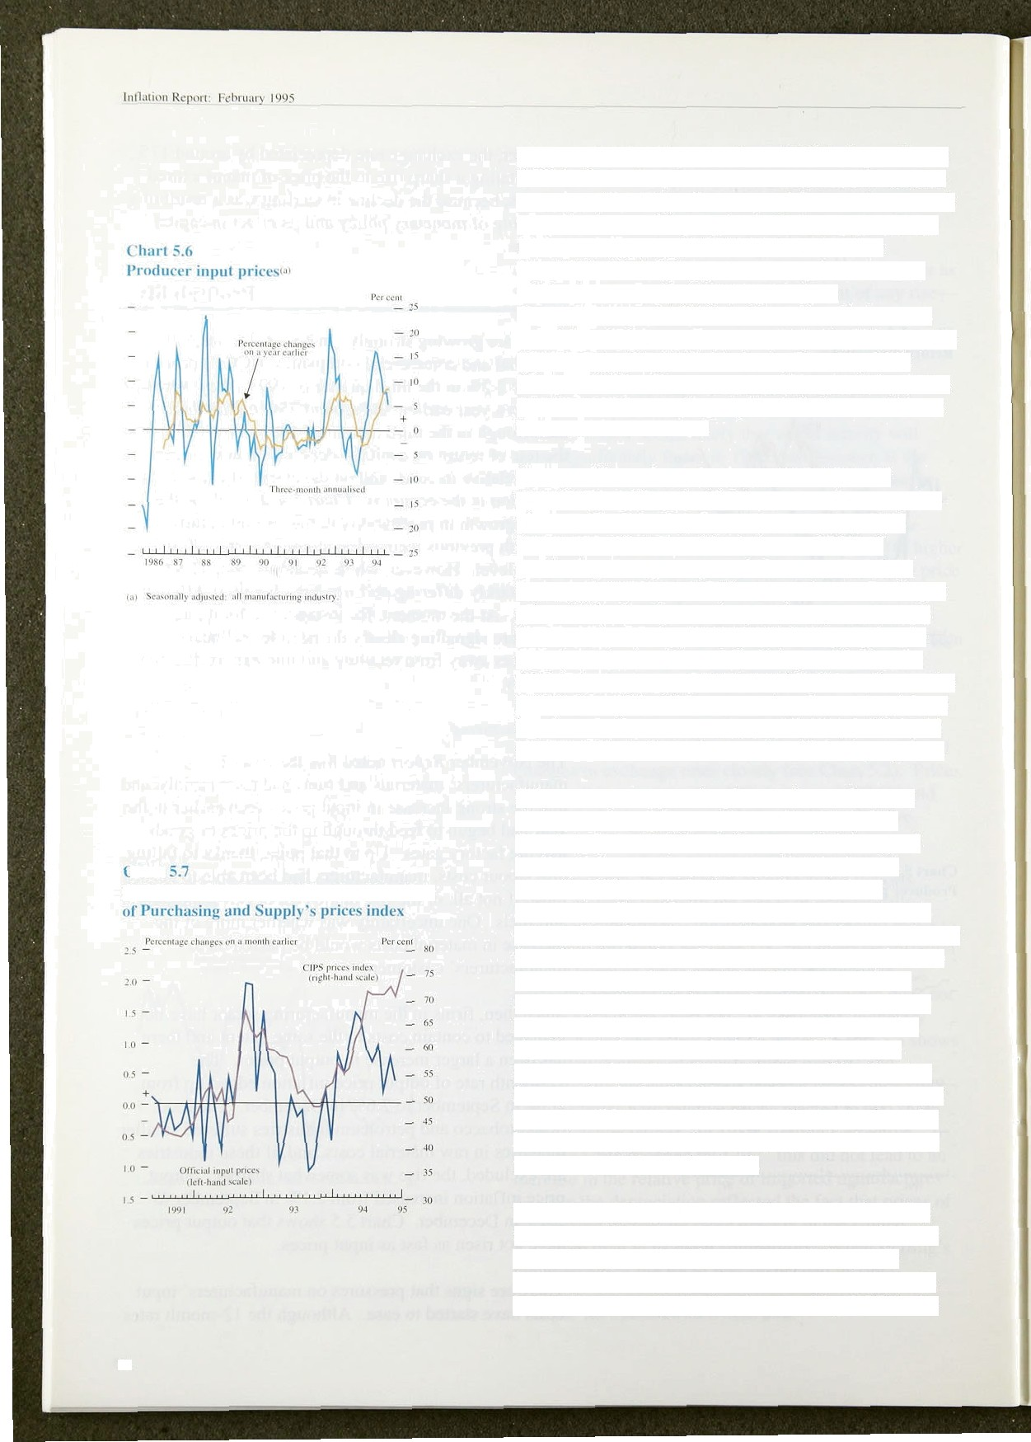

**’hart**

I tfJiciai input yricus and C'h»rtt•rcd **institute**

Other surveys support the picture of manufacturers facing consistent price pressures. The !atest **CBI** Quarterly Industrial Trends Survey. which is a good leading indicator of output prices (see the box on page 38 of November’s *Report ),* showed that a seasonally adjusted balance of 24% of manufacturers

expected to raise prices over the coming four months, up from 22% in October. There is still a considerable gap between hope and reality. The **CBI** reported that a seasonally adjusted balance of 14% of firms reported higher selling prices over the previous four months, significantly lower than the balance of firms who expected to increase prices at the time of the October Survey. On the basis of the past statistical relationship between CBI price expectations and output prices, the latest data suggest producer output price inflation will Increase to nearly 4% by April.

In addition, price pressures within the manufacturing sector are still intense. The official measure of output prices does not reflect the amount paid for goods exchanged between manufacturing firms. If these are included, *gross* output prices increased by 3.8T• in the



**.Chart SP**

**Manufacturers’ output prices**



- 3









year to December, compared with 2.9&o in September; they reached a trough of 2.2& in July. The gross measure of output price inflation has now exceeded the net measure for almost a year. Over periods, the annual

rate of output price inflation in the two series tend to move together. But short-term divergences are not unusual. The fact that the gross measure is running ahead of the net measure may mean that costs will soon start to feed through to higher output price inflation.

The question is whether current market conditions are simply delaying the pass-through into final output prices or actually reducing it. The last time the gross measure moved to exceed the net measure significantly was in 1987 (see Chart 5.8), with the gap between the two series peaking at 0.7 percentage points—much less than its current level. In that episode, a gap persisted for as long as two years; it was eventually closed in 1989 when net output price inflation rose sharply.

In part, the outlook for producer prices depends on unit wage costs. The main reason manufacturers were able to absorb input cost increases last year was because labour productivity rose sharply: manufacturing unit wage costs fell by 1.5% in the year to the third quarter, enabling firms to protect their margins without raising prices. Shorter-run measures show that manufacturing unit wage costs reached a turning-point in the summer (see Section 4). It is likely, therefore, that manufacturing margins fell as a proportion of output in the third quarter compared with the previous three months, although they were significantly higher than in the same period a year

###### .earlier.

Profitability in the manufacturing sector also depends on capacity utilisation. The CBI Quarterly Trends Survey reposed that the percentage of firms working below capacity declined further to 49a»—the lowest since

July 1990.

Utilities prices added to inflationary pressure during 1994. ,Despite pricing formulae which require electricity and gas to aRoib ine see in distribution costs, dt›mes(e eleetrieity bills increased byj l2st over 3&o .In 1994, and household gas bills rose more sharply. This



, lmgely because higher generation cests were passed

., . , cm tq.the consumer. Household water bills rose by

› 7& fn 1994 and the emphasis on quality

fiem6ntñ meians that they are likely to continue

" "e.g-

fiister than!the headline rate of inflation over



thart >.9

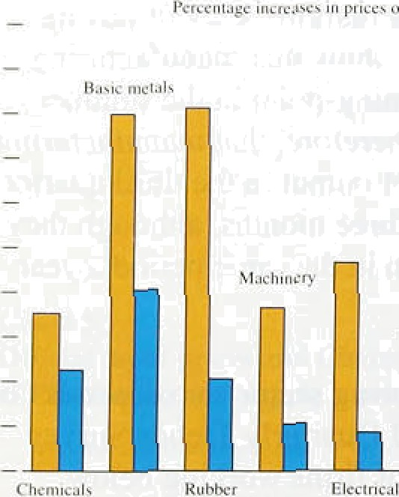**Flanu1âcturers’ input und output prices.**





— 10

Tampen - 6

*ftetaifing*

Retailers’ input prices have been rising less rapidly than those in the manufacturing sector, but they have been less successful than manufacturers in holding down average costs. Bought-in goods account fOf the .majority of retailers’ costs and their prices rose by around 3'/›&r in the year to the third quarter. Unit labour costs in retailing have also been increasing over the past year—at around the same rate as RPIY goods .inflation. Retailers’ margins probably fell again, therefore, in the third quarter. Some of the decline in margins probably reflects deep-roote‹i .structural change: supermarket price wars cut food retailers' margins; the rise in

out-of-town shopplng centres and the proliferation of discount stores also had an impact; Sunday trading added to wage costs, but had .little effect on .sales. But some of the squeeze on margins was probably cyclical, and will reverse during the recovery. There was some sign that margins strengthened in December, as retailers anticipated a pick-up in consumer demand in the run-up to Christmas. Tliis could unwind if demand falters. But if less of.the decline in margins seen over the past couple of years proves to be permanent than anticipated, this will pose a longer-term threat to the inflationary outlook.

The contrast between .the buoyant manufacturing sector and:the subdued retai.ling sector can be seen by comparing the behaviour of input and output prices along various stages ,of the supply chain. Chan 5:9 shows that companies which su to i!ndustry—such as rubber and plastics, metals and chemicals have seen the!greatest increases in input.costs and have also been able. to push through the highest price rises. B.ut companies closest.to the consumer—such as producers



of electrical goods—have been„unab1e.io pass on much of even modest increases In input prices.

pktsiics ,

The January Dun and Bradstreet survey.of business

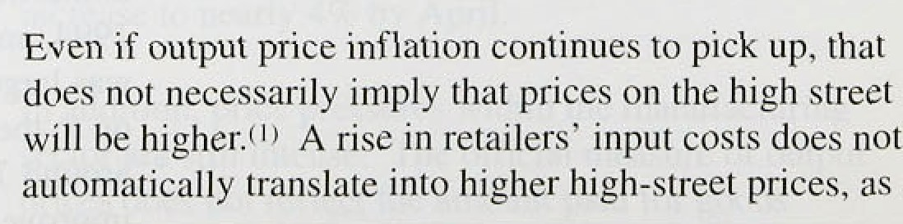executives underlined the diificulty .retailers face in passing on any cost increases to their customers: although the balance of’manufacturers who expected to increase prices over the current quarter zose from 28to in October to 49%,. the balance. of retailers .expecting to raise prices increased from just 30&o to:33&•.



38

the relationship between retail prices and producer prices runs in both directions. Producer prices clearly affect retail prices because of wholesale costs, but

retailers set prices with regard not only to their costs, but also to demand conditions .and the stance of monetary policy. If policy does not accommodate innation—and this is clearly perceived retailers will be forced to

.reduce other costs to maintain margins or increase sales volumes. Hence they may put pressure on their suppliers to cut prices, and on their employees to accept lower real wages than otherwise.

**Chart 5.10**

**Ratio .of RPIY goods to producer pr#p**

**t°i**

— I20

— 116.

— i«

In addition, recent experience suggests that there has been technological innovation in the retail sector; Chart 5.10 plots the ratio of **RPIY** goods prices to producer prices. The declining trend implies that the

prices of **RPIY** goods have risen less rapidly than those of their suppliers over long periods: that is, RPIY goods inflation has tended to be more subdued than output price i.nf1ation.

### 5 3 S a

— i»i The price of UK consumption-weighted commodities

'* .has risen less steeply over the past year than other

„ indices of commodity prices. It is likely that most of the p p p q— « rise has already fed through to input prices. Although

short-run measures of input price inflation have staned to slow, input price rises are still putting pressure on manufacturers’ margins—particularly at intermediate stages of the supply chain. In the first half of 1994, higher input prices in manufacturing were offset by falling unit wage costs; this is no longer happening. If output prices increase faster, this is likely to feed through to higher prices on the high street.

39



 

This section identifies the main economic news since the November *Report* and assesses the implications for inflation prospects. It presents the Bank's central projection for two years ahead and explains the uncertainty surrounding it.

### The economic news

###### Previous sections have described:recent economic developments and their implications for inflation. Some of the news has been bad for inflationary prospects:

UK output growth now appears to have been stronger through most of 1994 than was previously thought. Although domestic demand has. been

.restrained, world demand has grown more.rapidly than expected, and net exports have increased.

Labour demand .has increased and unemployment has fallen more sharply than expected. Pay settleinents have edged up.

###### Capacity utillsatior is well above its historical average, according to the CBI, and more firms report that they plan to raise prices this year.

Inflation was .higher than expected in the last quarter of 1994, particularly in December. It now looks as if inflation began to turn up in late 1994 rather than, as expected, early 1995. Retail margins have been higher than anticipated.

Most commodity prices and manufacturers’ input prices have been rising rapidly. Short-run meas:ires

.of costlinflation suggest that the pressure on margins from this source has eised a little, but it is

.still considerable.

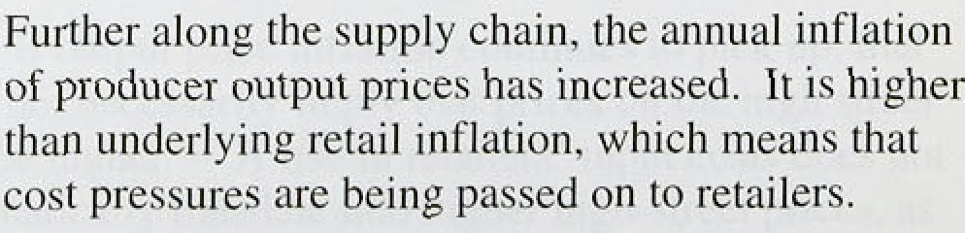



Narrow money .growth has started to fall, as expected, now that the adjustment to last year’s low interest rates has almost run its course. Short-run measures of M4 growth have picked up recently, but the 12-month rate is still below the middle of its

3ta—9Ro monitoring range.

Underlying earnings growth remained at an annual rate of 3'/‹% in November, despite the tightening labour market. Unit labour costs started to rise in the summer, but are still lower than a year ago.

Consumer demand has been growing only slowly, and is likely to continue to do so. The sluggishness tends to keep retailers’ margins under pressure.

*o* Firms have not been able to charge the prices they were expecting to in the autumn.

Consideration .of the inflation outlook led to decisions to raise interest rates twice during the past three months, by half a percentage point each time, on 7 December and

2 February.

* 1. **The Bank’s medium-term inflation**

### o e t on

Each quaner, the Bank extends its projection of inflation out by another three months; it is now looking as far ahead as 1996 Q4. Both RPIX and RPIY inflation are projected to be about the same in two years’ time as the Bank envisaged last November. The inflation projection incorporates the likely effects of the past rate increases: like all such projections, it is based on the assumption of no further change in official interest rates.( )

The most important evidence of increased inflationary pressure is the faster-than-expected growth of both the ldemand for labour and output. Unemployment fell by nearly 50,000 a month in the last quarter of 1994. considerably more than expected. The tightening labour market is likely to lead to a faster rise in nominal unit labour costs, even though .earnings growth may increase only a little. It is not surprising that labour costs adjust to, increased labour demand only after a delay, given that wage rates are adjusted in annual pay rounds. The uicrease in deiiiand'for goods and services is already

:being **fiflected in** the prices charged by suppliers and

###### .retailers, and..smirk of the price.increases reflect stronger



lnlnbon Rem F<bcu:



**RPI1’ fttflatJon outturns and projections**





RPTX **inflation uutturns and pmjcctiuns**



.demand in world markets. Although culprit growth slowed in the:second half of. 1!994, .it was still at an annualised rate of about 3.% a year,'faster than can be sustained in the long run. As with the labour market, it is not just the amount of slack—the output ga that matters, but also how quickly it is taken up; in some.

' industries supply is slow to adjust. The sharp dichotomy between export and domestic demand has meant that the

* capacity of producers of tradable goods and services has come under particular pressure.

The recent increases in base.rates in the United Kingdom have yet to affect demand significantly. But they will help to.dampen the faster-than-expected growth discussed above, by stimulating saving and reducing borrowing. Higher interest ratgs should also affect price expectations, by convincing more people of the authorities’ commitment to low inflation in the medium. term. If inflation expectations fal!, this will make it less likely that firms will raise both wages and prices. In the short term, however, recent survey evidence suggests

”"’ ""” ’“ ”* """“"* • that wage settlements.and wholesale price inflation are

likely to edge up.



Chart 6d



**Quarterly percentage change in RPIT**

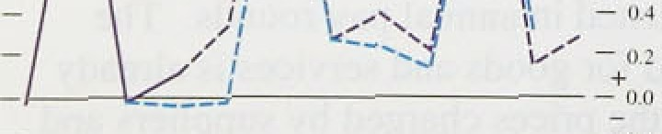



‹t2



2.0

Charts 6.1 and 6.2 show .the outturns and central projections for the 1,2-month RPIY and **.RPIX** inflation measures. Both are expected.to be about the same in two years’ time as the Bank anticipated in November.. But both are signiflCrantly .higher in the short run, as the strengthening of retail margins seen in December is expected to continue. Higher margins push up the projection of the 12-month .inflation rates, by increasing

the projected. price *lev.el.,* But.this effect will last for only

:about.a year; and, a!1though the.quarterly inflation rates. in 1994 Q4 and 1995 Q1 are higher.,than. the Bank.

.projected last time, the quarterly projections from, 1995 Q2 are little altered (see Charts 6.3 and 6.4). Both RPIY and **.RPIX** inflation are projected to begin falling towards the end of this year, as recent.polieyltightening starts to take effect.

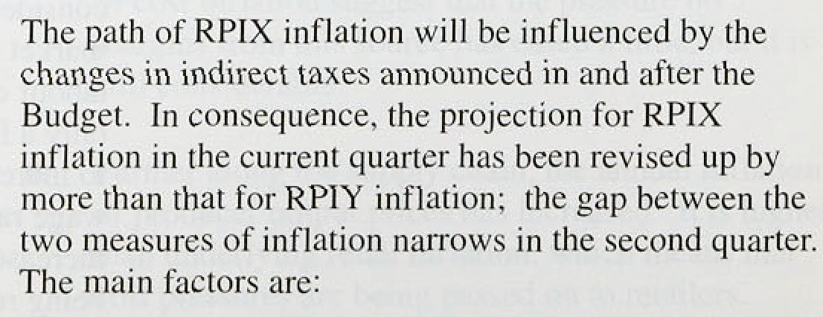

0 **The** éxcise dntiqs amounmd **in the nudget** and the Chidqe!lof’ suliplemeutaryetatâ.mast. Togetlva,

Chart6.4

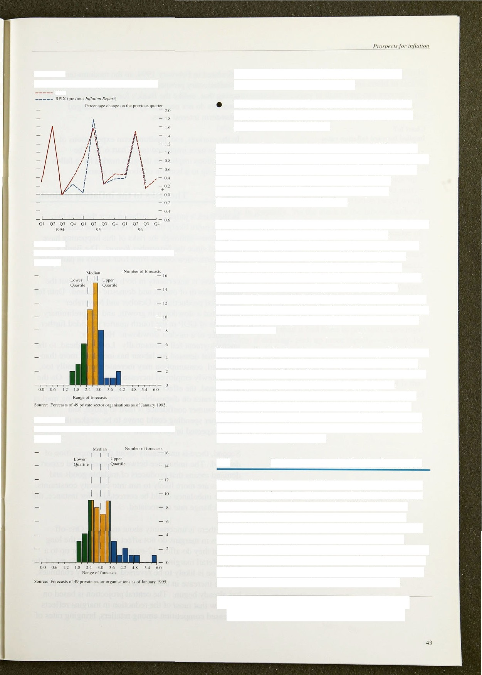

Quarterly percentage change in RPIX

Chart G.5

Distribution *of* RPIX inflation forecasts for 1995 Q4

Chart 6.6

Distribution of RPIX inflation forecasts for 1996 Q4

these are likely to add 0.39 to the price level previously expected in 1995 Q1.

The cancellation of the increase in VAT on fuel, which is likely to lower the previously expected price level from 1995 Q2.

Any projection is bound to be uncertain. All forecasts are subject to a margin of error, so presenting them in the form of point estimates can be misleading. For policy purposes, the range of likely outcomes. and the probabilities attached to them, are often just as significant as the central projection.

The Bank’s central projection should be thought of as the single most likely outcome, or the *mode* of the probability distribution of inflation. It is impossible to be precise about the exact shape of the distribution.

However, for reasons explained below, the Bank’s judgment is that the risks to inflation are asymmetric at the moment. In other words, the distribution is skewed: it is more likely that the outcome will be above the central projection than that it will be below, although. in the Bank’s judgment, the upside risks are somewhat less than before.

The central projection is now around the top of the lower half of the Government’s target range. There is a high probability that RPIX inflation will turn out to be within the Government’s 1%—4% target range. But the probability of it being in the lower half of the range is less than the probability of it being in the upper half.

Were it not for the projected increases in indirect taxes. there would now be a better chance of remaining in the lower half of the target range.

### Private sector inflation forecasts

Taking all the forecasts of inflation prepared by private sector economists, there has been a further reduction in their median figure for 12-month RPIX inflation in 1995 Q4; it is now below 3% (see Chart 6.5). For 1996 Q4, their median forecast is 3.1% (see Chart 6.6).

More than four fifths of the 49 forecasts put RPIX inflation within the Government’s target range at the end of 1996, but only a fifth expect it to be in the lower half of the range. Both these groups are considerably larger than they were when the two-year forecasts were

lli general, the distribution could be skawed to the left, to the right, or not ai all, depending on the economic circumstances at the time. For ihis rcasnn, the symmetric shading dnnotiag the scale of psst forecast errors has keen dropped from Charcs 6.1 and 6.2.



thart 6.7

**Ix1pIied fnr** t **i\rd inllatinn rates**

calculated in Febniary 1994, so tlie medium-term view of inflationary prospects has improved. But it is worth noting that, unlike the Bank’s forecast, private sector forecasts do not necessarily assume unchanged

short-term interest rates.

In the markets, too, medium-.term expectations of

* + 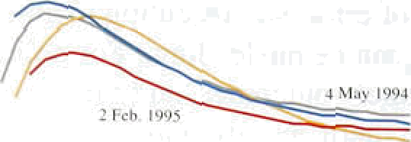••• , inflation have i.mproved (see. Chart 6:7): The expectations imp1:icit in the gilts market have fallen slightly up to a horizon of about ten years.

## The risks to the inflation outlook

In the Bank’s judgment, inflation over the next two years is more likely than not to exceed:the central projection—although the risks of this happening have declined since the November *Report.* The Bank’s asymmetric view comes from four factors in particular.

First. there is uncertainty in both ‹directions about the future growth of output and domestic demand. Data for industrial production in October.and November suggested a slowdown in growth, and the preliminary estimate of GDP in the fourth quarter provided further evidence of a moñest slowdown. However, unemployment fell substantia!l1.y. Lookirig:ahead, to the eKtent that demand for lañourl has increased more than expected, consumption may. increase.more rapidly too, as the newly employed increase their spending. lOn the other hand, the effect of.recent increases in taxes and interest rates on disposable incomes, the housing market and consumer confidence is hard to gauge, and consumer spending could prove to be weaker than the! Bank expected in November.,

Second, there is uncertainty about the composition of dema'nd. The imbalance between domestic and export . demand.means that producers of tradable goods and services are more likely to rub iiito:eapacity constraints. But the imbalancelcould be eorrected if, for instance, the real exchange rate appreciated.

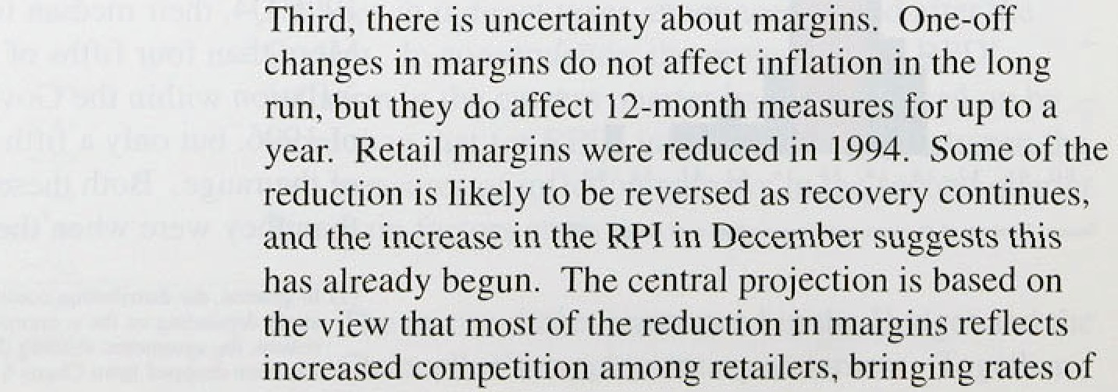

retu*rn* oloser to ratea abroad, and is therefore likely to be permanent. However, retailers’ margins could in fact return.to something closer to their long-run average; on the other hand, the slight increase in December might not be maintained—particularly if consumer confidence falls further.

Fourth, there is uncertainty about nominal earnings growth. Unit labour costs are likely to rise simply because productivity growth tends to slow at this stage in

the cycle. If nominal earnings growth were to pick up , even quite modestly, it would push the growth in unit

lahour costs above 29c or so. The inCation target would then be in jeopardy. As the slack in the labour market is used up, employees are likely to push for higher real pay—and employers are less likely to resist, because of the rise in profitability and their need to retain skilled workers. Unless inflation expectations fall, this process would translate into higher nominal earnings. So far, nominal earnings have grown quite slowly. The central projection assumes that the short-run trade-off between increases in nominal earnings and output growth will be similar to that in the late 1980s, when nominal earnings

DWth was less sensitive to changes in the rate of growth of output than it had been in previous upswings. However, if earnings pick up more rapidly—as they did, for exampte, in the 1970s—the extra pressure on costs would add to inflation. The latest increase in interest rates makes this less likely. In addition, the greater the credibility of the inflation target, the less likely it is that expectations will push up nominal earnings growth, and the easier it will be to achieve the target.



i*'.'!(* ' '

.F›•.-ir"

. ,i .

' *° • "



Producer price inflation started to rise in 1994. It is now clear that retail price inflation also turned up in the final quarter of last year. The headline rate of inflation rose from 2.2' c in September to 2.9é• .in December, and will rise further as higher indirect taxes and mortgage rates affect the index. Underlying RPIX inflation rose from 2.0% in September to 2.5% in December. Underlying **RPIY** inflation, which excludes both indirect taxes and mortgage interest payments, rose from l.29c to l.7Ho over the same period.

These I 2-month measures are, however, poor guides to turning-points. They reflect events at the end of 1993 dropping out of the index as much.as price changes at the end of 1994 entering the index. It is therefore more helpful to look at three-month annualised measures of inflation. These turned up only in December: RPIX inflation rose from 2.6% in September to 3.2% in December, and **RPIY** inflation from l.29r to 1.6%.

Output.has continued to grow ,at well-above.!trend, though it slowed do,wn. during 1994. The data suggest that in the first half of last year output was .gmwing at an annualised rate of well over 49c, ,slowing to añout 3% in the second half.

The sharp contrast between export and domestic:demand has, if anything, intensified.since the November *Report.* Exports remain very buoyant, and prospects in the Unlted .Kingdom’s main foreign markets. in .1995 are good. .But growth in real domestic deirrand has fallen over the pdst year and.v!irt ually stopped in the,third quarter of 1994. Consumption growtñ. slowed in the first quarter of 1994, and.has.sinee!remaimed below 2 .

a yes The.combination.of(a) the rise in the:.yield curve.

over the past year and (b) a further round. of tax increases to take effect in the first half, of 1995 means that consumption growth:is likely.to. stay close.to its trend rate.

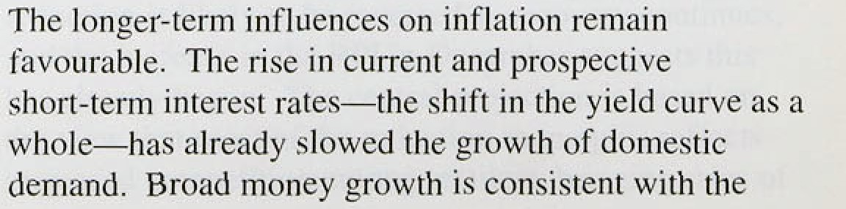

##### inflation target. Growth in narrow money has adjusted to earlier large reductions in interest rates, and has fallen sharply in recent months.

In .the short run, there are still strong pressures from the costs side. Manufacturing input prices rose by 8.She in the year to December. But the rate of increase of input prices slowed considerably in the second half of last year, with the three-month annualised rate falling from 16.0' o in June to 5.3&o in December. Output prices within manufacturing are rising faster than prices charged to final customers. and the CBI again reported an increase in the proportion of firms expecting to raise prices. Retail price inflation is likely to pick up during 1995, as some of the squeeze on retail margins unwinds. But the Bank’s central projection for RPIX inflation two years ahead is about the same as in November, at a level of around 2'/the.

###### The chief uncertainties about the central projection were identified in the November *Repon.* First, the outlook for activity: output growth has already fallen, demand has yet to reflect the full impact of the monetary tightening of 1994 and early 1995, and there will be a further round of tax increases in the first half of this year. Second, the dichotomy in the recovery means that capacity pressures, especially in manufacturing, are sensitive to the composition of total demand. Rapid export and investment growth would place further pressure on

manufacturing capacity. Third, the rise in producer input and output prices may feed through to retail prices by more than anticipated. Although some of last year’s compression of retail margins is likely to unwind as recovery continues, much of the reduction in margins is, in the central projection, assumed to be permanent, refleeting a structural increase in retail competition.

That is only an assumption: the probable long-run level of margins is hard to gauge. Fourth, the ability or firms to abaorb increases in input prices has depended on their reducing their unit wage costs. As unemployment falls. the cyclical recovery in productivity is likely to slow down, leading to faster growth in unit wage costs. This would be exacerbated by any increase in earnings growth. So far, earnings growth has been encouragingly atahleas the economy has re’covered, but there is no eertain;y thgl this will continue.

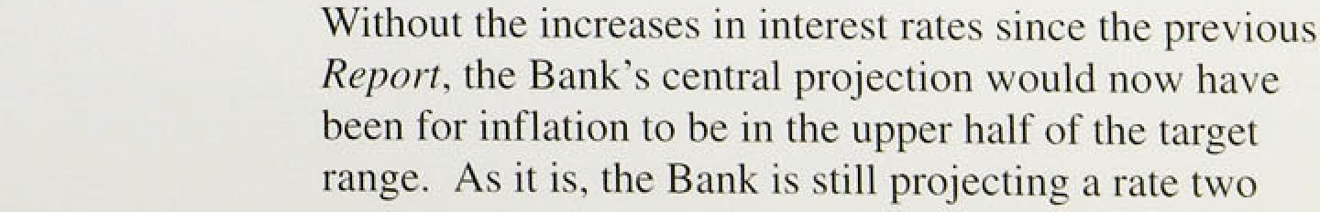

years ahead of’ aiound 2'/i%, the mid polnt of the range—with the upside risks somewhat less than befoi’e. The tightening of monetary policy since November has therefore improved the prospect of achieving the lower half of the target range by the end of the present parliament.



Price fi4.00